Research Project

VOLUNTEERS NEEDED
Physical and Cognitive Status of People Aged 50+ With & Without Fibromyalgia (FM): A Longitudinal Study
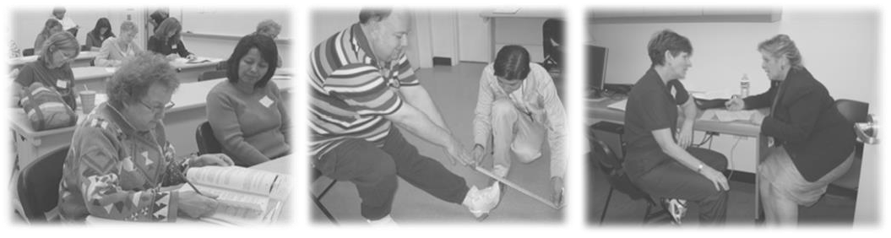
Where: California State University, Fullerton Kinesiology & Health Science (KHS) Building

Dates: |  | Friday, 10/5, 10/19, 11/2, or 11/16 | 9am or 1pm
 | or | Sat., 10/6, 10/20, 11/3, or 11/17 | 9am or 1pm

**Call Now for an Appointment! (657) 278-7031**
(Appointments take place on ONE DAY and will last approximately 2 ½ - 3 hours)
Purpose of Study: The purpose of this study is to determine changes in the physical and mental performance of people aged 50+ with and without fibromyalgia. Secondary objectives are to determine if: (1) earlier physical activity level and current physical performance influence mental status; and (2) to determine whether factors such as physical activity and medication use impact changes in performance.

TO PARTICIPATE, YOU MUST BE:
- aged 50+ years
- community-residing and functionally independent (not using a wheelchair)
YOU CANNOT PARTICIPATE IN THE STUDY IF YOU:
- have been advised by your physician NOT to exercise
- have ever experienced congestive heart failure
- currently have chest pain, dizziness, or pain in chest during exercise or
- are unable to walk for 6 minutes without assistance

**RECEIVE OVER $350 OF TESTING plus A PERSONALIZED REPORT**

If you have any questions and/or would like to schedule an appointment, please contact us at (657) 278-7031 or fmcp@fullerton.edu

