

Multiple Dimensions of Balance are Adversely Affected in Older Adults with Fibromyalgia

Danielle Hernandez, Debra J. Rose, Camila Guimaraes, Dana Rutledge, & Jessie Jones California State University, Fullerton, CA. United States

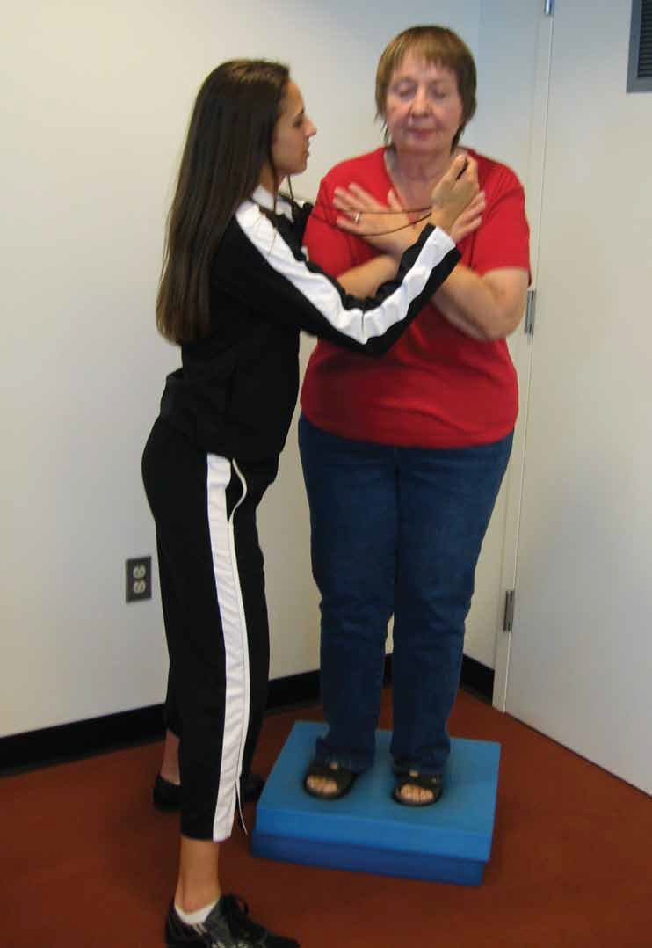
Introduction
Individuals diagnosed with Fibromyalgia (FM), a musculoskeletal pain disorder that is characterized by widespread bodily pain and tenderness of unknown origin, frequently report symptoms of imbalance, tingling and numbness in the extremities, painful neuropathies, and dizziness when surveyed [1]. These symptoms, coupled with the aging process, are likely to result in higher levels of sedentary behavior, physical de conditioning, and heightened risk for falls due to impairments. To date, only one study has attempted to identify how these symptoms impact the different dimensions of balance and mobility in younger adults [2]. The goal of this study was to address this important question with a group of older adults with FM.

The Fullerton Advanced Balance (FAB) Scale
The Fullerton Advanced Balance (FAB) scale [3] includes 10 items that assess the functional limitations associated with balance and mobility disorders. The FAB scale is scored using a zero to four ordinal scale. Scoring is based on time to complete a given task, the duration of time a specific position can be maintained without losing balance, and/or the quality with which a task is performed. This scale, which was originally designed to evaluate the multiple dimensions of balance in independently functioning older adults, has also been shown to be a reliable measure of balance when administered to individuals with FM [4].
For additional information regarding test protocol for the FAB scale refer to Rose, Lucchese, and Wiersma [3].
For the purpose of this study, individual test items on the FAB scale were divided into four new variables, each one representing a dimension of balance (see table 1). For each dimension, the sum of all the individual FAB items that comprise a dimension was divided by the total number of items in that dimension resulting in a total dimension score. For example, the total dimension score for static balance was determined by adding the score on item 2 and the score on item 6 and then dividing this sum by 2. This method of creating the subscales resulted in a consistent range of total scores (0-4) across the dimensions.

Table 1 - FAB scale Dimensions

Static Balance
item 2  item 6 | Reach forward to retrieve object Stand on one leg
Dynamic Balance
item 3  item 4  item 5  item 8 | Turn in a full circle  Step up and over 6 inch bench Tandem walk  Two-footed jump
Sensory Reception and Integration
item 1  item 7  item 9 | Stand with feet together & eyes closed Stand on foam with eyes closed  Walk with head turns
Reactive Postural Control
item 10 | Reactive postural control

Methods
Multiple dimensions of balance were assessed in a group of 69 older adults (M = 60, SD=7.62) with a confirmed diagnosis of FM (OAFM) and a group of 75 healthy, older adults (OAH) (M=68, SD=8.77) as part of a comprehensive evaluation of cognition and physical function.
Specifically, the four dimensions of balance (static balance, dynamic balance, sensory reception and integration, and reactive postural control) were evaluated to determine whether there was a significant difference between OAFM and OAH groups. Group differences were investigated using a Multiple Analysis of Covariance (MANCOVA) with age as the covariate. Roy-Bargmann’s Stepdown Analysis was used as a follow-up test to separately assess the dependent variable by removing the effect of shared variance.
Important demographic information was obtained using a Health Activity Questionnaire (HAQ) prior to the administration of the physical performance tests. The HAQ provided information related to medical history, medication use, level of cognitive function (using the Mini-Mental scale) as well as a retrospective fall history report (based on history of falls in the previous 12 months). In addition, self-reported physical activity levels were also included on the HAQ.

Table 2 – Demographic Characteristics of Participants with and without Fibromyalgia

 | OAFM |  | OAH |  | Group Differences
 | M | SD | M | SD | p-values
Age * | 60 | 7.62 | 68 | 8.77 | p < 0.001
Body Mass Index | 28.9 | 7.30 | 26.9 | 4.87 | p = 0.061
Number of Medications | 6 | 3.95 | 4.07 | 3.69 | p = 0.641
Mini-Mental Exam | 29 | 1.53 | 29 | 1.58 | p = 0.894
Number of Falls * | 1.8 | 1.42 | 1.7 | 1.05 | p = 0.002
Total FAB Scale Score* | 32 | 6.34 | 34 | 4.65 | p = 0.015
* Statistically significant F values

Results
Demographic information indicated there was no significant difference in Body Mass Index, number of medications, and mental status between OAFM and OAH. There was a significant difference between groups for age, number of falls, and the total FAB scale score. A significant group difference was evident for the combination of dependent variables (Pillai’s F (4, 138) = 6.636, p < 0.001) analyzed. Follow-up univariate analyses further indicated that the groups differed significantly in the dimensions of static balance (F (1, 141) = 15.228, p < 0.001), dynamic balance (F (1, 141) = 19.279, p < 0.001), and sensory reception and integration (F (1, 141) = 13.687, p < 0.001) with the OAFM group scoring significantly lower on each of these balance dimensions. No significant group difference was evident for the dimension of reactive postural control (F (1, 141) = 2.265, p = 0.135).

Discussion
The results of this study confirm previously published self-report findings and suggest that the balance problems identified result from impairments in both the sensory and motor systems. These results are similar to those found by Jones and colleagues [4] who compared the performance of patients with FM (mean age = 47, SD = 10.88) to age-matched healthy controls using the BESTest [5]. Patients with FM performed significantly worse on five subsystem categories (e.g., stability limits, anticipatory postural adjustment, reactive postural response, sensory orientation, and stability in gait). Although no significant differences were observed in reactive postural control abilities in the present study, this was possibly due to differences in test protocols used to investigate this dimension of balance between the studies. Alternatively, differences in reactive postural control abilities may be less evident when comparing older adults because age-associated changes in this dimension of balance likely affect healthy older adults as well as older adults with FM, albeit to a lesser degree. Further studies are needed to elucidate the specific cause(s) of the balance problems identified and evaluate the efficacy of tailored intervention strategies that address the identified balance problems.

References:
- Bennett RM, Jones J, Turk DC, et al. An internet survey of 2,596 people with fibromyalgia.
BMC Musculoskel Disord. 2007; 8: 27.
- Jones KD, Horak FB, Winter-Stone K, Irvine JM, and Bennet RM. Fibromyalgia is associated with impaired balance and falls. J Clinic Rheumatol. 2009; 15:16-21.
- Rose DJ, Lucchese M, Wiersma L. Development of a multidimensional balance scale for use with functionally independent older adults. Arch Phys Med Rehabil. 2006; 87:1478-85.
- Flores G. Establishing test-retest reliability of the short-form version of the Fullerton Advanced Balance scale in individuals with fibromyalgia. Unpublished Master’s Thesis, California State University, Fullerton, 2008.
- Horak F, Frank, J, Wrisly D. The balance evaluation-system test (BESTest): development of a clinical tool to differentiate types of balance deficits. Phys Ther, (In press).

