
BMI Levels and Pain Indices in Hispanics with Chronic Pain
Jordan K. Aquino, BS¹  Dana N. Rutledge, RN, PhD¹  C. Jessie Jones, PhD¹  Patricia Cantero, PhD²  Alejandro Espinoza, MPH²  Brianne Levine, BA¹ Elizabeth Blache¹
¹California State University, Fullerton  ²Latino Health Access, Santa Ana, California

Background
- Obesity and chronic pain have been associated with lower quality of life and are risk factors for other debilitating health conditions.^{1,2}

- However, research is limited on the relationship between weight and pain in the Hispanic population.

Objective
- To describe the relationship between body mass index (BMI) and pain indices (severity, pain troublesomeness [PT], number of pain sites) among ambulatory, low-income, overweight/obese Hispanic persons with chronic pain.
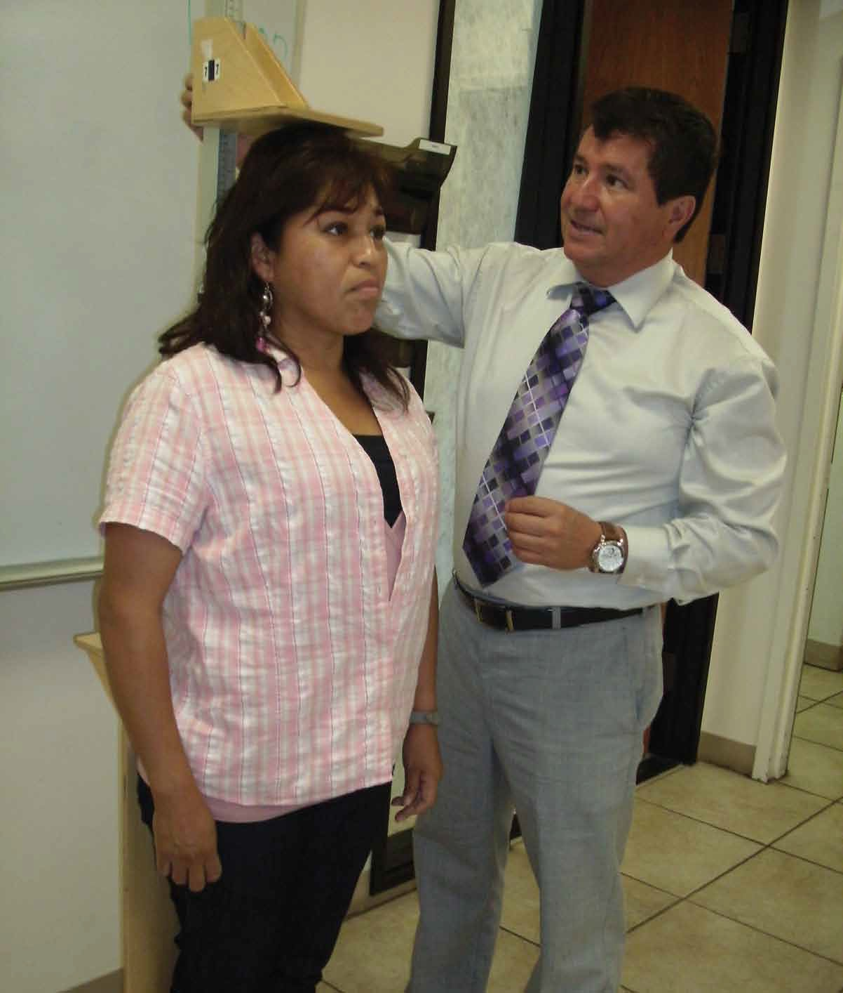

Methods
- This participatory action study involved promotores from the community who interviewed subjects in Spanish about varying health issues.

- Height and weight were measured using calibrated tools, allowing calculation of BMI.

- All interview questions were translated into Spanish using translation/back translation methods.
- Pain indices were intensity (0-10 numeric rating scale), PT (14-item scale, range=0-70), and number of pain sites (sum of PT scores >0 for 14 sites).

Results
- In this sample of 101 persons, predominately female (80%) and Mexican American (97%) participants had an average BMI of 34.3 (World Health Organization categories: over weight, 27%; obese, 55%; extremely obese, 19%), a pain intensity of 6.84, a PT score of 28.0, and 8.4 pain sites.
(Table 1)

- Associations between BMI and pain intensity were not significant (r=0.16, p=0.112), while the relationships between BMI and PT (r=0.29, p=.004) and BMI and number of pain sites (r=0.24, p=0.017) were significant. (Table 2)

- One-way ANOVAs showed nonsignificant, but important trends by BMI levels, with greater obesity associated with greater negative pain outcomes. It appears that the degree of obesity affects PT and number of pain sites more than pain intensity.
Table 1. Demographics and Pain Measures by Age Group (n = 101)

Table 2. Associations between Pain and BMI Levels (n = 101)
 | Mean (SD) or %
Demographic characteristics | 40-49  n = 46 | 50-59  n = 36 | 60+  n = 19
Gender  Female | 85% | 81% | 68%
Anthropometric measures
BMI (calculated from height and weight) Overweight (25-29.5)  Obese (30-39.5)  Extremely obese (39.6 or greater) | 28%  57%  15% | 28%  44%  28% | 21%  68%  11%
Waist circumference (inches) | 42.7 (5.8) | 43.5 (5.5) | 43.4 (4.8)
Pain Measures
Pain intensity (0 – 10 scale) | 6.9 (2.1) | 7.3 (2.3) | 5.8 (3.0)
Pain troublesomeness (14 sites; 0 to 5 response set where 5 = extremely troublesome) | 30.0 (13.4) | 27.4 (15.2) | 24.1 (13.2)
Number of pain sites 2  3-5  ≥6 | 4%  13%  83% | 3%  17%  81% | 16%  11%  74%

 | Mean (SD) or %
 | BMIª | WCª | Overweight: BMI 25-29.4  n = 27 | Obese:  BMI 30.0-39.9  n = 55 | Extremely obese: BMI 40.0 and above n = 19
Chronic widespread pain (above and below the waist, on left and right side of body for > 3 months) | .117 (.245) | .078 (.440) | 48% | 66% | 63%
Pain intensity | .159 (.112) | .178 (.074) | 6.3 (2.7) | 7.1 (2.2) | 6.9 (2.5)
Pain troublesomeness (PT) | .289 (.004)* | .208 (.038)* | 25.3 (13.4) | 27.0 (13.2) | 34.4 (16.0)
Number of pain sites | .238 (.017)* | .202 (.043)* | 7.9 (3.6) | 8.3 (3.3) | 9.4 (3.1)
Pain interference | -.082 (.413) | .093 (.356) | 74% | 66% | 63%

Note. BMI = body mass index. WC = waist circumference.
ªPearson product moment correlations with level of significance.
*p < .05

Conclusions
- Obesity has long been associated with an increased risk of developing multiple chronic medical conditions and chronic pain among the general population.

- This is the first known study to report the relationship between obesity and pain indices in a low-income, Mexican-American, Spanish-speaking population.

- This study provides valuable information for public health professionals and healthcare providers in determining appropriate treatment, service provisions, and prevention programs for Mexican Americans.

- Clinicians should consider an integrative approach and incorporate strategies to include medications and complementary modalities that address the comorbidity of excessive weight and chronic pain, and the potential underlying issues leading to these conditions.

- In addition, a chronic pain self-management program in Spanish with an emphasis on weight management should be developed.

Disclosure
- This study was funded by the Centers for Disease Control and Prevention.

References
- Bryant L, Grigsby J, Swenson C, Scarbro S, Baxter J. Chronic pain increases the risk of decreasing physical performance in older adults: the San Luis Valley health and aging study. J Gerontol. 2007;62A(9):989-996.

- Janke EA, Collins A, Kozak AT. Overview of the relationship between pain and obesity: what do we know? Where do we go next? J Rehabil Res Dev. 2007;44(2):245-262.

