Typology of Chronic Pain Among Overweight Mexican Americans
C. Jessie Jones, PhD*  Dana N. Rutledge, RN, PhD*  Jordan K. Aquino, BS*  Laura Zettel-Watson, PhD*  Patricia Cantero, PhD**; Alejandro Espinoza, MPH**  Francisca Leal, B.S**  Belinda Prado, BS*  Connie Valencia, BS*  Jie W. Weiss, PhD*
*California State University, Fullerton  **Latino Health Access, Santa Ana, CA

Background
- Obesity and chronic pain are both major public health conditions of increasing prevalence, particularly among disadvantaged Hispanics in the United States.

- Having a better understanding of the intersection between chronic pain and obesity among the Mexican American community can be valuable for public health professionals in determining appropriate treatment, service provision, and prevention programs.

Objective
- To describe the location, severity, and bothersomeness of chronic pain among low-income, overweight or obese Hispanic adults with chronic pain.

Methods
- Using a community-based participatory research (CBPR) method, trained promotores interviewed 101 Hispanic (predominately Mexican American) participants in Spanish about varying health indices: health status; type, severity, and bothersomeness of pain; access to care; acculturation; social support; self-efficacy; psychological distress; and physical activity level. Questions were translated into Spanish using translation/back translation methods.

- Pain indices were intensity (0-10 scale), pain troublesomeness (PT; 14-item scale, range = 0 - 70), number of pain sites (sum of PT scores > 0 for 14 sites), presence of widespread pain (pain above/below the waist AND on left/right sides of body for > 3 months), and pain interference (whether pain interfered, during last 4 weeks, with normal work using 5-level response set, not at all to extremely).

- Participants were measured for BMI and waist circumference (WC). BMI categories used were: overweight 25 - <30; obese 30 - <40; extremely obese ≥ 40. WC was acquired using a standard protocol (location: two fingerbreadths above iliac crest).

Results
- Table 1 presents key characteristics of the 101 participants shown in age categories (40-49, 50-59, 60+). Most were female (80%), born in Mexico (97%), and ranged in
age from 40 to 79 (M = 52).

- A substantial number suffered from chronic medical conditions such as diabetes (50%), cardiovascular disease (52%), rheumatic conditions (30%), and uncorrected visual problems (21%). A minority reported rheumatoid (9%) or nonrheumatoid (13%) arthritis, fibromyalgia (2%), or neuropathies (9%).

- As shown in Table 2, most participants (60%) reported chronic widespread pain. The mean number of pain sites was 8.4 (SD=3.3), with 87 participants reporting 5 or more locations. Pain intensity for the past week averaged 6.84 (SD=2.4; 0-10 scale) with 60% of subjects suffering severe pain (>7). About two thirds of the sample reported moderate or greater pain interference with work.

- As seen in Table 3, the most common pain location was head (80%), followed by knee and upper back (both 75%), shoulder (74%) and lower back (73%).
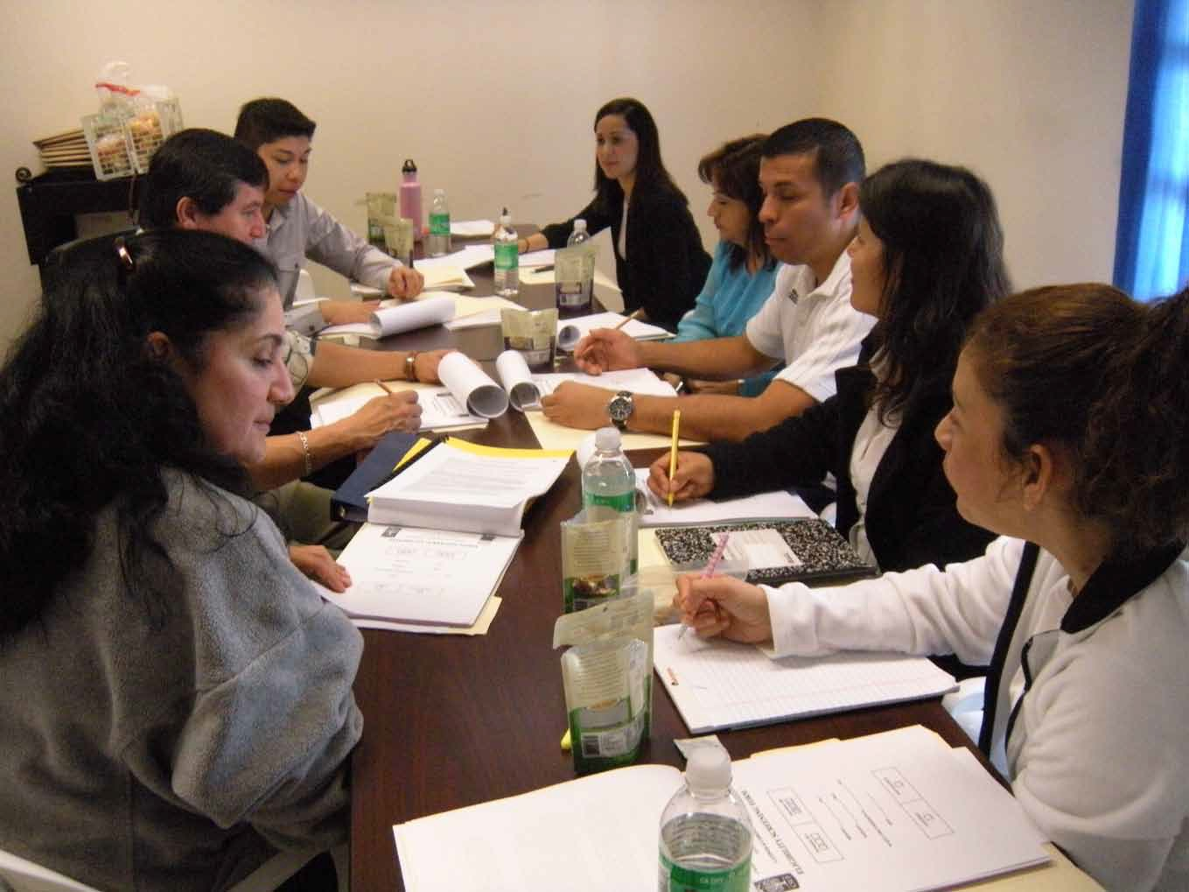
Community-based participatory research team
TABLE 1 - Sample (n = 101) Demographic Characteristics, Acculturation, Anthropometric Measures, Health Status, and Access to Healthcare by Age Group (40-49; 50-59; 60+)
 |  | Mean (SD) or %
 | 40-49 | 50-59 | 60+
Demographic characteristics | N = 46 | N = 36 | N = 19
Gender, Female | 85 | 81 | 68
Education (# of years)* | 7.7 (3.8) | 6.1 (3.3) | 4.1 (3.7)
Current marital status*
Never married | 33 | 22 | 21
Divorced/separated | 22 | 3 | 5
Widowed | 2 | 11 | 21
Married | 44 | 64 | 53
Current employment status
Working fulltime | 13 | 19 | 16
Working parttime | 26 | 19 | 21
Looking for work or on temporary leave | 34 | 39 | 10
Permanently disabled or retired | 2 | 6 | 16
Other | 24 | 17 | 37
Acculturation
Age when moved to US*** | 24.2 (8.4) | 32.5 (9.4) | 42.8 (15.1)
Years in US | 19.7 (7.7) | 21.5 (8.2) | 22.0 (14.0)
Anthropometric measures
BMI (calculated from height and weight)
Overweight (25-29.5) | 28 | 28 | 21
Obese (30-39.5) | 57 | 44 | 68
Extremely obese (39.6 or greater) | 15 | 28 | 11
Waist circumference (inches) | 42.7 (5.8) | 43.5 (5.5) | 43.4 (4.8)
Health status
Depressive symptoms | 7.4 (5.1) | 7.4 (4.9) | 4.6 (5.2)
General quality of life
Excellent | 4 | 3 | 16
Very good | 11 | 3 | 0
Good | 50 | 67 | 74
Fair | 28 | 22 | 5
Poor | 7 | 6 | 5
Short-Form 12, Health Status
Physical function | 39.4 (9.0) | 39.0 (8.2) | 36.0 (10.1)
Mental function | 42.6 (10.8) | 44.3 (11.2) | 44.3 (10.8)
Diabetes | 41 | 50 | 58
Cardiovascular condition (heart attack, transient ischemic attack, angina, hypertension, stroke, peripheral vascular disease)** | 26 | 67 | 63
Respiratory disease | 11 | 22 | 5
Neuropathy or Parkinson’s disease or multiple sclerosis | 7 | 11 | 21
Rheumatoid or chronic pain condition (arthritis, rheumatoid or other; fibromyalgia, joint replacement)* | 15 | 28 | 47
Uncorrected vision problems | 24 | 33 | 16
Inner ear problems/recurrent ear infections | 11 | 36 | 19
Respiratory disease | 11 | 22 | 5
Osteoporosis | 4 | 11 | 11
Psychiatric conditions | 2 | 0 | 0
Otherª | 22 | 36 | 37
Access to Healthcare in Past 12 Months
Had visited the following….
Medical doctor | 85 | 97 | 95
Other medically trained professional* | 63 | 72 | 89
Emergency room, urgent care center, hospital | 17 | 33 | 21
Health care provider in Mexico | 4 | 6 | 5
Traditional healer such as curandero or botanica | 15 | 3 | 5
Other (examples sobador – masseuse, support group) | 11 | 3 | 5
Needed to see doctor, but did not go | 59 | 53 | 32
Was prescribed or given medication, but did not get or take medication | 48 | 47 | 26
Payment method
Cash or credit* | 74 | 61 | 37
Private health insurance or HMO | 9 | 14 | 16
Medicare | 0 | 3 | 11
Medi-Cal | 7 | 6 | 16
Do not seek health care | 2 | 0 | 0
Cannot pay | 24 | 25 | 26
ªExamples of conditions - high cholesterol, lupus, thyroid problems, specific pain sites or conditions
*p < .05; ** p < .001; ***p < .0001

TABLE 2 - Pain Measures

TABLE 3 - Location and Troublesomeness of Pain Symptoms during Past Month (n = 101)
 | Mean (SD) or %
Pain Measures | 40-49  N=46 | 50-59  N=36 | 60+ N=19
Percent of sample with chronic widespread pain ( > 3 months above and below the waist and on both sides of the body) | 70 | 58 | 42
Pain intensity (0 – 10 scale) | 6.9 (2.1) | 7.3 (2.3) | 5.8 (3.0)
Pain troublesomeness (14 sites; 0 to 5 response set with 5 = extremely | 30.0 | 27.4 | 24.1
troublesome) | (13.4) | (15.2) | (13.2)
Number of pain sites 2 | 4 | 3 | 16
3-5 | 13 | 17 | 11
>5 | 83 | 81 | 74
Percent of sample reporting moderate or greater pain interference with work during past 4 weeks | 63 | 72 | 68

 | Troublesomeness
Symptom | No pain | Not at all | Slightly | Moderately | Very | Extremely | M (SD)
Head ache | 20 | 7 | 26 | 21 | 13 | 14 | 2.42 (1.6)
Neck pain | 28 | 8 | 13 | 21 | 16 | 15 | 2.34 (1.8)
Jaw/teeth pain | 48 | 14 | 14 | 5 | 12 | 8 | 1.44 (1.7)
Shoulder pain | 27 | 2 | 14 | 22 | 15 | 21 | 2.58 (1.9)
Elbow pain | 58 | 9 | 8 | 8 | 13 | 5 | 1.25 (1.7)
Wrist/hand pain | 39 | 7 | 14 | 17 | 13 | 11 | 1.91 (1.8)
Chest pain | 62 | 9 | 10 | 11 | 3 | 6 | 1.03 (1.5)
Abdominal pain | 46 | 7 | 13 | 11 | 11 | 12 | 1.70 (1.9)
Upper back pain | 26 | 5 | 15 | 17 | 16 | 22 | 2.57 (1.9)
Lower back pain | 27 | 7 | 7 | 12 | 21 | 27 | 2.73 (2.0)
Hip/thigh pain | 32 | 5 | 11 | 11 | 19 | 23 | 2.49 (2.0)
Knee pain | 25 | 6 | 14 | 12 | 16 | 28 | 2.71 (2.0)
Ankle/foot pain | 35 | 5 | 14 | 14 | 15 | 18 | 2.23 (1.9)
Other painª | 93 | 0 | 1 | 4 | 3 | 0 | .34 (1.2)

Note. Numbers in columns 2-7 are percentages.
ªOther pain sites mentioned: pelvis, bones, throat, face.

Conclusions
- We found substantial levels of troublesome and intense chronic pain from a variety of causal conditions in participants who were not using medical management for their pain.

- Our findings support results from several other studies indicating that obesity is associated with a variety of musculoskeletal conditions (e.g., low back pain, knee and hip osteoarthritis, headaches).

- Future research should focus on low-cost interventions to help prevent, screen and treat comorbid obesity and chronic pain to reduce physical frailty and permanent disabilities, and to improve quality of life, especially with vulnerable, minority populations.

References
Flegal K, Carroll MD, Ogden CL, Curtin LR. Prevalence and trends in obesity among US adults, 1999-2008. JAMA 2010;303(3):235-241.

Parsons S, Carnes D, Pincus T, et al. Measuring troublesomeness of chronic pain by location. BMC Musculoskeletal Disorders; 2006;7(34).

Ware JEJ, Kosinski M, Keller SD. A 12-item short-form health survey. Construction of scales and preliminary tests of reliability and validity. Med Care 1996;34(3):220-233

Disclosure: This study was funded by the Centers for Disease Control and Prevention

