Experiences with a Balance/Mobility Program: Case Study in FM
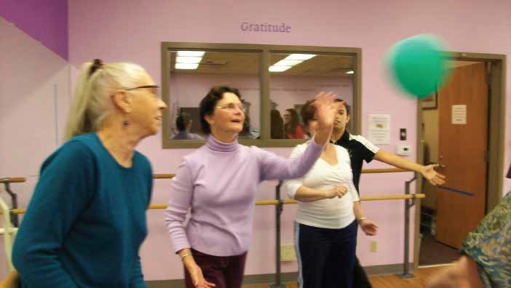
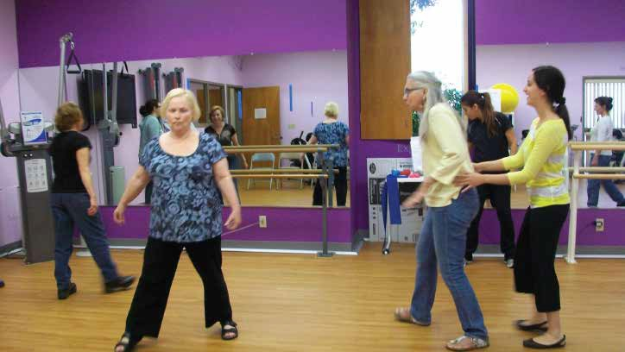
Dana N. Rutledge, PhD, RN (drutledge@fullerton.edu) Jacob Melendez, BS, Danielle Johansen, BS, Debra J. Rose, PhD

Physical and Cognitive Measures over Time
Results
FallProof!
Method
Background
Measure (range, M (SD), Mdn)

Baseline

Pre

Post
a

Final

- Persons with ﬁbromyalgia (FM), a chronic pain

Recruitment
12-week program - comprehensive balance/

Sample and Adherence
N = 5

condition, have poorer postural control and mobility than do age-matched peers, sometimes with altered gait dynamics.

- These factors may account for increased fall rates at younger ages.

- It is unknown whether persons with FM at risk for falls can beneﬁt from balance/mobility programs.

Purpose
- To describe experiences with a balance/ mobility program for adults with FM 50+ years of age who had a history of falls or postural instability
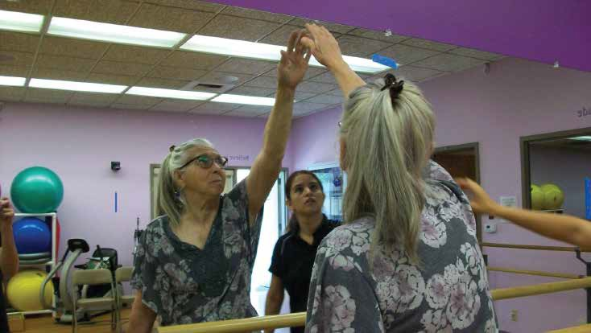

- Fibromyalgia and Chronic Pain Center database of recent study participants
- Eligibility
  - FM
  - 50 years of age or greater
  - Fallen within the past year OR scored 5+ on numeric rating scale for postural instability
Enrollment in pilot study to evaluate eﬃcacy of the FallProof!™ program

Outcomes
- Balance (Fullerton Advanced Balance scale; 0 to 40)
- Gait velocity (calculated from 30-ft walk: ft/sec)
- Executive function
  - Stroop Color & Stroop Color/Word- selective attention, cognitive ﬂexibility, processing speed (# correct responses)
  - Digit Symbol Substitution Test – processing speed (# correct responses)
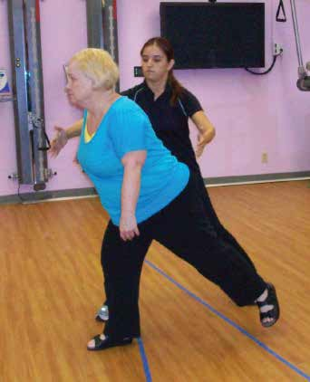
- Fall incidence (monthly fall diaries)

Timeline
T1 (baseline)
T2 (pre-program, 12 weeks later) T3 (post-program)
mobility program developed for community dwelling older adults at moderate-to-high risk for falls (Rose, 2010).

- Targets systems contributing to postural stability and mobility.

- Taught by certiﬁed instructor in 2 x week classes in a movement enhancement laboratory on a university campus.

- Class activities followed standardized lesson plans; individualization done by altering level of challenge associated with progressive activities.

Data analysis

- Descriptive statistics; content analyses.
- 7 women, ages 56-77 years, took part.
- Oldest woman dropped the class (week 5) stating she found the exercises diﬃcult.
- Class attendance for other participants varied: 36-87% classes; 24-97% minutes possible.
- Absences for 2 women: illness (shingles) and problems with house sale.

8-week Evaluation
- Written comments weeks 8-9 of FallProof!
  - All perceived their balance to be improving
  - Half reported improved ability to control posture while standing and sitting
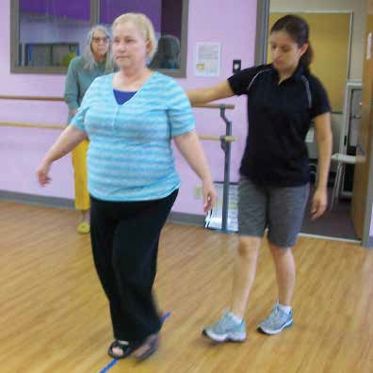
  - Half reported that a minority of the classes had a negative eﬀect on FM symptoms, but that the “soreness” was the “good kind, [and was] worth it.”

gait velocity and other cognitive measures.
Fullerton Advanced Balance Scale (0 to 40)

Walk velocity (ft/sec), preferred *
 | 3.7 | 3.8 | 3.8 | 3.7
Walk velocity (ft/sec), maximal * | 3.9-6.2 | 4.7-7.5 | 3.8-6.3 | 4.6-9.1
 | 5.3 (.8) | 5.8 (1.0) | 5.6 (1.1) | 6.4 (1.5)
 | 5.5 | 5.6 | 6.2 | 6.0
Walkie talkie test (# who passed) | Not done | 6 | 5 | 6

Stroop C Response Time (sec)

Stroop C (errors)

Stroop CW Response Time (sec)
 | 144.6 (33.0) |  | 138.8 (24.6) | 151.2 (32.8) | 134.0 (39.4)
Post-program (T3) | 135 |  | 139 | 151 | 117
- All women improved on overall balance scores | Stroop CW (errors) | 0-6 | 0-10 | 0-4 | 0-4
(3-31% improvement) |  | 2.3 (2.3) | 2.2 (3.9) | 1.4 (1.5) | 1.4 (1.5)
and Stroop CW (measure |  | 1.5 | .5 | 1.0 | 2.0
of interference; 4-15%
improvement) | Digit Symbol Span (# correct) | 57-85  69.2 (12.0) | 56-76  66.5 (8.8) | 52-79  68.4 (13.2) | 50-88  74.3 (14.7)
- Variable responses on | 68 |  | 66.5 | 77 | 80.0

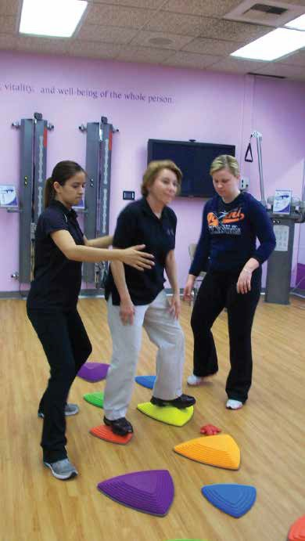
Note. N = 6.
19-36
29.8 (6.3)
32.0

3.0-4.3
5.3 (.6)

49-94
64.8 (15.7)
61

0-1
.33 (.52)
0

115-209
18-35
29.3 (7.4)
33.0

3.6-6.0
4.2 (.9)

53-90
64.7 (14.0)
60

0-0
0
0

114-177
19-36
31.4 (7.1)
34.0

1.7-4.2
3.4 (1.0)

56-87
68.8 (11.3)
67

0-0
0
0

119-202
19-39
32.6 (6.5)
34.0

3.3-4.8
3.9 (.6)

45-109
66.5 (21.8)
56

0-0
0
0

89-204

- Findings support further evalua- tion of balance/mobility programs for persons with FMS who have a moderate-high fall risk.
Implications and Recommendations for Future Studies

- Future study is needed to deter- mine if a class devoted speciﬁcally to persons <65 years could allow for greater progression in activities and possibly lead to clinically sig- niﬁcant changes in performance (physical/cognitive).

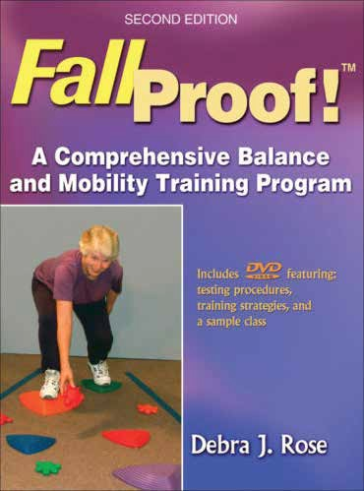
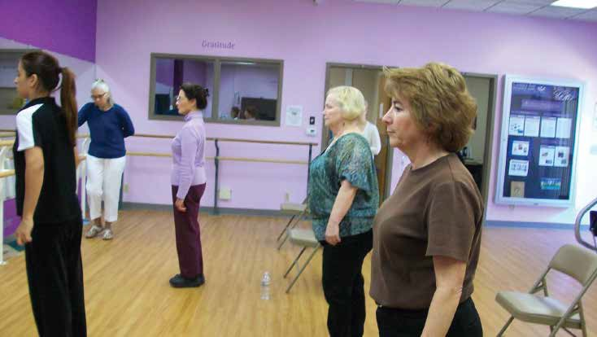
T4 (12 weeks later)
aOne participant had to leave the country at week 10 of the balance/mobility program and did not complete
post-program assessments.
*Calculated using 30 ft walk



