
Longitudinal Change in Cognitive and Physical Measures in Fibromyalgia
Cortez, F.*  Melendez, J.*  Rutledge, D.N.**  Jones, C.J.ŧ  Zettel-Watson, L.*  & Cherry, B.J.* California State University, Fullerton
*Department of Psychology  **School of Nursing  ŧDepartment of Health Science

- Chronic widespread pain syndrome

Fibromyalgia
Procedure
- 2008: Two 60 min. sessions, tested individually

Table 2. Results: Cognitive
 | Non-Fibromyalgia group: M (SE) |  |  | Fibromyalgia group: M (SE)
Cognitive | Baseline | 2 years | 4 years | Baseline | 2 years | 4 years
EPT ratio (#/min.) | 1.31 (0.05) | 1.40 (0.05) | 1.42 (0.06) | 1.12 (0.05) | 1.23 (0.05) | 1.24 (0.06)
Stroop C (s) | 60.59 (1.36) | 58.25 (1.39) | 60.04 (1.75) | 62.06 (1.37) | 60.41 (1.33) | 62.47 (1.73)
Stroop CW (s) | 146.56 (3.99) | 137.07 (4.30) | 140.73 (6.09) | 154.66 (4.06) | 149.12(4.05) | 149.26 (5.87)
DSF (#) | 9.68 (0.23) | 10.33 (0.30) | 9.57 (0.36) | 9.92 (0.24) | 9.93 (0.30) | 10.13 (0.37)
DSB (#) | 6.94 (0.24) | 6.84 (0.27) | 6.63 (0.35) | 6.55 (0.24) | 6.93 (0.27) | 6.52 (0.36)
Trails A (s) | 35.40 (1.61) | 31.62 (1.91) | 30.84 (2.63) | 39.50 (1.62) | 32.71 (1.87) | 32.75 (2.75)
Trails B (s) | 86.00 (4.06) | 87.06 (5.99) | 88.18 (8.59) | 86.48 (4.25) | 86.88 (5.85) | 87.95 (8.67)
DSS (#) | 63.58 (1.72) | 70.20 (1.59) | 70.17 (1.87) | 59.34 (1.73) | 65.39 (1.49) | 66.04 (1.82)
Animals (#) | 21.29 (0.59) |  | 20.43 (0.94) | 19.33 (0.66) |  | 18.80 (1.00)
BP 0 (#) |  | 4.82 (0.08) | 4.99 (0.03) |  | 4.98 (0.08) | 4.93 (0.04)
BP distr (#) |  | 2.70 (0.17) | 2.93 (0.18) |  | 2.10 (0.17) | 2.25 (0.19)

Results

- Cognitive

Conclusions


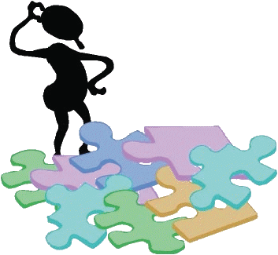
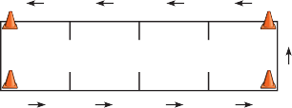
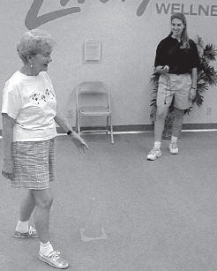
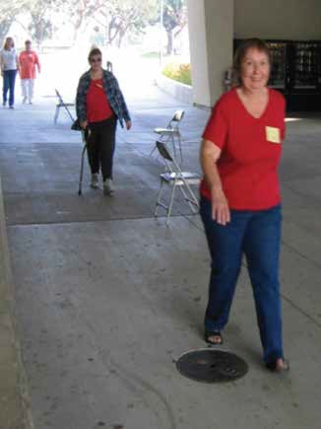
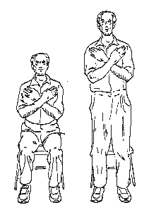
  - Central sensitivity syndromes (Yunus, 2006)
13
10
8
9
I
D
B
4
3
7
Begin
1
5
H
C
12
G
A
J
2
L
6
E
F
K
11
Trail Making Test B
Cognitive Assessments
- Mini-Mental State Examination
- Everyday Problem Test
- Stroop Color/Word
- Digit Span Forward
- Digit Span Backward
- Trail Making Test A
- Trail Making Test B
- Digit Symbol Coding
- Brown Peterson (2)
- Category uency (2)
- CERAD 10-item word list (1)
EPT: Questions on Health/medication Finances Transportation
1 2 3 4
Digit Symbol Coding

Digit Span
XTZ
768 – 3….
CERAD 10-item word list Immediate recall Delayed recall Recognition
71504
284936
8351609
25736184
940627135
2753180649
Stroop Color-Word Test
Name the color of the ink in which the word is printed.
Stroop (1935)

BLUE GREEN YELLOW PINK RED ORANGE GREY BLACK PURPLE TAN WHITE BROWN
1 5 4 2 7 6 3 5 7 2 8
Physical Assessments
- 30-second chair stand
- 8-foot up and go
- 6-minute walk
- Three of five measures from the Senior Fitness Test
(Rikli & Jones, 2001)
- Fullerton Advanced Balance scale
- Walk velocity (30 feet)
  - Fast; Preferred
  - Not reported here
30-second chair stand (lower body strength/endurance)
6-minute walk
(aerobic endurance)
45 yds
40 yds
35 yds
30 yds
25 yds
50 yds
Start
5 yds
10 yds
15 yds
20 yds
8-foot up and go
(agility and balance)
Fullerton Advanced Balance (FAB) Scale
- Measures static and dynamic balance
  - 10-items
  - Up to 40 points
  -   scores   better balance

- Step up and over
- Tandem walk
- Stand on one leg, eyes open
- Stand on foam, eyes closed
- Stand with feet together, eyes closed
- Reach forward to retrieve object
- Turn in a full circle
- Two footed jump for distance
- Walk with head turns
- Unexpected backward release
- best predictors of fall status
30-foot walk
(gait)
Dana Rutledge
2013-08-08 20:17:25
--------------------------------------------
can these bullets be spaced differently? large space in between FM and 76, 51, 57
- 5-6 million U.S.; 3-6% worldwide affected
  - (75-95% women)
- Potential cognitive and physical functional decline, as well as increased risk for falls (Rutledge et al., 2010)

Research Questions
- Over a four year period, are there changes in cognitive and physical performance?
- Are changes different for FM versus non-FM participants 50 years of age and older?

Longitudinal Study Overview
- Participants
  - 2008 70 FM76 non-FM
  - 2010 64 FM51 non-FM
  - 2012 46 FM57 non-FM
- Measures
  - Medical history, medications, BMI, physical activity level (RAPA), MOS social support survey
  - 19 symptoms (NFMAQ), Composite Physical Function, Beck Depression Inventory
  - Cognitive, physical performance

Methods: Participants
Table 1. Demographic Characteristics at Baseline (first of at least two time points)

 | FM |  |  |  | Non-FM
Characteristics | n | Mean | SD | Range | n | Mean | SD | Range
Age (years) | 97 | 59.63 | 7.41 | 50-97 | 87 | 67.82 | 8.57 | 50-87
Education (years) | 97 | 16.21 | 2.69 | 12-20 | 87 | 16.94 | 2.59 | 12-20
Body mass index | 95 | 29.39 | 7.39 | 16.30-54.90 | 86 | 27.31 | 4.84 | 18.70-45.00
Female (%) | 97 | 94.85 |  |  | 87 | 71.26
Race (%) | 94 |  |  |  | 87
Caucasian |  | 89.36 |  |  |  | 88.51
African American |  | 2.13 |  |  |  | 0.00
Asian/Paci c Islander |  | 0.0 |  |  |  | 10.34
Other |  | 2.13 |  |  |  | 0.00
Multiracial |  | 6.38 |  |  |  | 1.15

Day 1
  - Informed consent
  - Demographics, medications, symptoms

Day 2
  - Beck Depression Inventory
  - Cognitive tasks
  - Physical tasks

- 2010, 2012: Two to three hour sessions on one day

Data Analysis
- Covariates associated with outcome variables
  - Cognitive, Physical—Age, Education
  - Symptoms—Body mass index (BMI)
- Missing data
  - PROC MIXED analysis in SAS
- Repeated measures analyses of covariance
  - Group (FM versus nonFM); Time main effects
  - Group by Time interaction
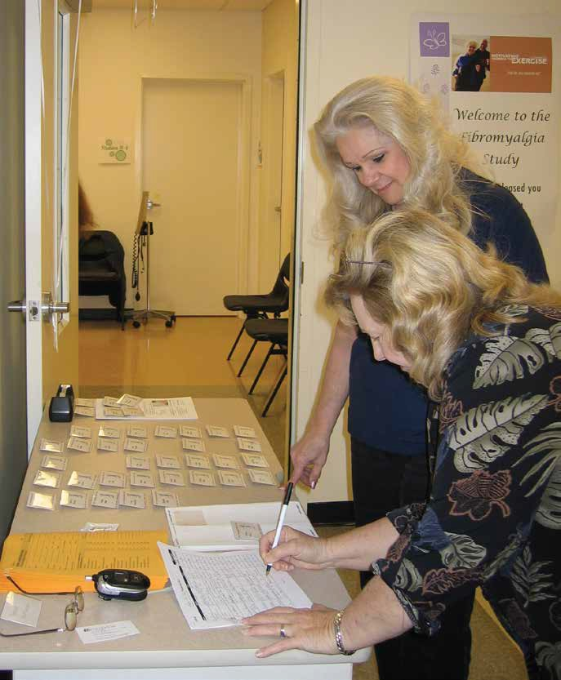

Table 3. Results: Physical
SAMPLES
2 | 1 | 3 | 7 | 2 | 4 | 8 | 2 | 1 | 3 | 2

*FAB = Fullerton Advanced Balance Scale—0 to 40; higher score = better balance
 | Non-Fibromyalgia group: M (SE) |  |  | Fibromyalgia group: M (SE)
Physical | Baseline | 2 years | 4 years | Baseline | 2 years | 4 years
FAB* | 34.19 (0.51) | 33.41 (0.56) | 33.40 (0.80) | 30.28 (0.52) | 30.51 (0.55) | 30.22 (0.85)
30 Second Chair Stand (# of stands) | 13.22 (0.41) | 13.98 (0.43) | 13.29 (0.54) | 9.84 (0.41) | 10.43 (0.42) | 10.74 (0.54)
8 Foot Up and Go (time in sec.) | 5.55 (0.20) | 4.94 (0.18) | 5.76 (0.22) | 6.38 (0.20) | 5.98 (0.18) | 6.86 (0.21)
6 Minute Walk (# of yards) | 600.33 (10.04) | 604.21 (11.84) | 600.04 (13.20) | 517.67 (10.52) | 504.27 (11.84) | 503.90 (13.20)

Table 4. Results: Symptoms
 | Non-Fibromyalgia group: M (SE) |  |  | Fibromyalgia group: M (SE)
Measures* | Baseline | 2 years | 4 years | Baseline | 2 years | 4 years
Pain | 1.97 (0.23) | 2.45 (0.31) | 1.49 (0.32) | 6.14 (0.22) | 5.68 (0.32) | 5.88 (0.35)
Fatigue | 2.01 (0.23) | 1.98 (0.29) | 1.95 (0.32) | 6.23 (0.22) | 6.38 (0.30) | 6.42 (0.37)
Not feeling rested after sleep | 2.74 (0.30) | 2.59 (0.33) | 2.63 (0.42) | 6.36 (0.28) | 6.07 (0.34) | 5.18 (0.47)
Morning sti ness | 2.54 (0.27) | 2.56 (0.35) | 2.16 (0.41) | 6.48 (0.26) | 5.98 (0.36) | 6.32 (0.45)
Forgetfulness | 2.03 (0.25) | 2.00 (0.29) | 2.11 (0.32) | 5.37 (0.24) | 5.68 (0.30) | 5.26 (0.35)
Concentration problems | 1.35 (0.25) | 1.26 (0.29) | 1.24 (0.33) | 5.43 (0.24) | 5.58 (0.29) | 5.23 (0.36)
Postural instability | 1.25 (0.24) | 1.11 (0.24) | 1.27(0.38) | 3.00 (0.23) | 2.65 (0.25) | 3.67 (0.42)

*0 to 10 scale, higher scores = worse symptoms
  - Executive function (Stroop Color/Word test, uency, problem solving) and
  - Processing speed (Digit Symbol, Trails A) showed both Group and Time main effects
  - Poorer performance FM versus non-FM
  - Change over time
  - No Group by Time interactions

- Physical
  - Balance (FAB)
  - Agility and balance (8-foot up and go) showed both Group and Time main effects
  - Poorer performance FM versus non-FM
  - Poorer performance over time

- Symptoms
  - FM versus non-FM reported higher symptoms over time on all items

- Limitations
  - Small sample size
  - Generalizability

- Future directions
  - Additional data points (e.g., 2014)

Selected References
Cherry, B.J., Zettel-Watson, L., Shimizu, R., Roberson, I., Rutledge, D.N., & Jones,
C.J. (2012). Cognitive performance in women aged 50 years and older with and without fibromyalgia. Journals of Gerontology, Series B: Psychological Sciences and Social Sciences, doi:10.1093/geronb/gbs122
Cherry, B.J., Zettel-Watson, L., Chang, J.C., Shimizu, R., Rutledge, D.R., & Jones, C.J. (2012).Positive associations between physical and cognitive performance measures in fibromyalgia. Archives of Physical Medicine and Rehabilitation, 93(1), 62-71. doi:10.1016/j.apmr.2011.08.006
Erickson, K.I., Gildengers, A.G., & Butters, M.A. (2013). Physical activity and neuroplasticity . Dialogues in Clinical Neuroscience, 15(1 ), 99-108.
Rutledge, D.N., Cherry, B.J., Rose, D.J., Rakovski, C., & Jones, C.J. (2010). Do fall predictors in older adults predict fall status in persons 50+ with fibromyalgia? Research in Nursing & Health, 33, 193-206.
Yunus, M.B. (2007). Fibromyalgia and overlapping disorders: The unifying concept of central sensitivity syndromes. Seminars in Arthritis and Rheumatism, 36, 339-356.

