Depression: Moderating the Effects of Stress and Chronic Pain in Older Adults with Fibromyalgia
Jonathan Castañeda1, Julie A. Kircher1, Han Duong1, Barbara J. Cherry, Ph.D.1,2, Laura Zettel-Watson, Ph.D. 1,2
California State University, Fullerton, Department of Psychology1 Gerontology Academic Program2

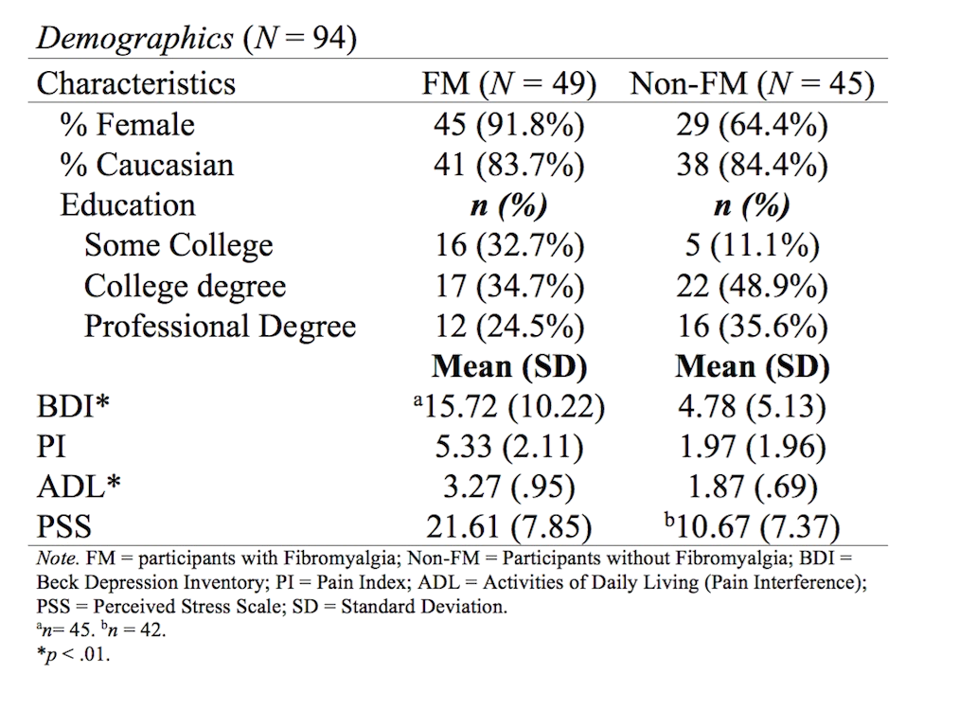
DISCUSSION




WHAT WE LEARNED

Perceived stress and depression may be risk factors for decreased health outcomes among those with chronic pain

INTRODUCTION
- Fibromyalgia (FM) - a condition characterized by chronic widespread pain
- Older age associated with FM
- Higher level of stress predicts higher level of depression
- FM patients with depression often report more pain related issues
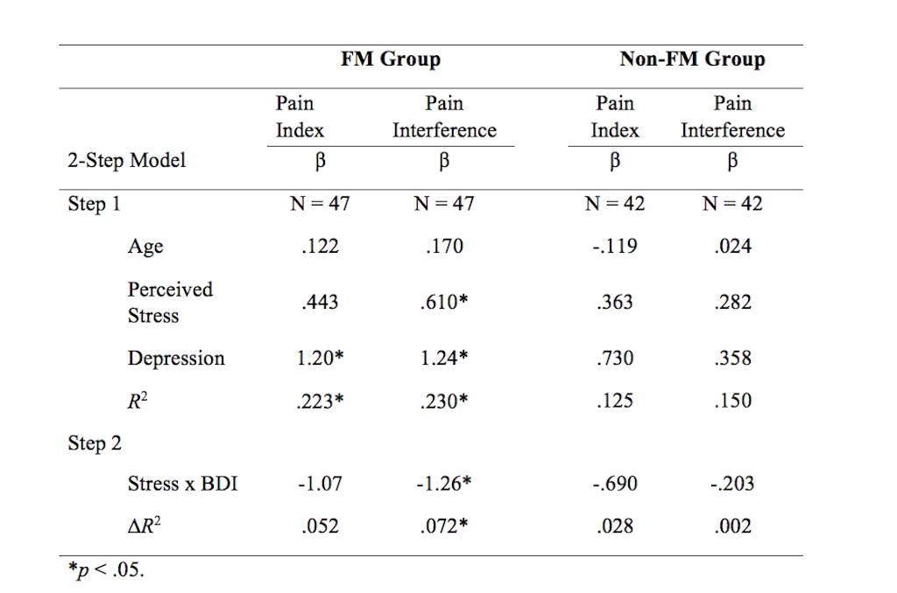
- Depression associated with stress level and chronic pain.
- Purpose: Examine how depression influences the relationship between perceived stress and chronic pain

METHOD

Measures
- Demographics (Age, Gender, Education)
- Perceived Stress Scale (Total)
- Beck Depression Inventory (Total)
- National Fibromyalgia Association Questionnaire
- Activities of Daily Living (Pain Interference)

- Hierarchical linear regressions to evaluate depression moderating perceived stress and chronic pain
In control group, stress and depression were not significant predictors, but were significant predictors for the FM groups on both pain measurements
Depression moderated the relationship between stress and pain interference
•
•
•
•
•
RESULTS
Depression did not moderate the relationship between stress and pain index
No main effect with stress among those with FM
When considering depression as a moderator, both depression and stress had main/direct effects

FUTURE DIRECTIONS
Moderation Model

Direct Pathway

Perceived Stress c
Chronic Pain:
2 measurements

Mediated Pathway
Perceived Stress c1
Chronic Pain:
2 measurements

a b

Depression

