

Introduction
- Diet regulation is one of the prime markers of health behavior and overall well-being
- Past literature discovered a strong association between high sugar intake and low cognitive abilities in aging adults (Ye et al., 2011)
- Previously, rats that ingested high sugar water found to experience greater oxidative stress than control group (Beilharz, Maniam, & Morris, 2014)
- In the past, adhering to a high fat diet resulted in slower learning abilities in the aging adults (Attuquayefio et al., 2016)

Hypothesis
- Old rats on a nutritionally balanced standard diet would perform better on cognitive learning tasks than rats on either a high-sucrose or high-fat diets
- There would be a difference in learning abilities between high-sucrose and high-fat diet groups

Methods
Subjects: 15-month-old male Sprague-Dawley rats
- Standard diet (4% sucrose, 1.5% saturated fat)
- High-sucrose (35% sucrose)
- High-fat (37% saturated fat)
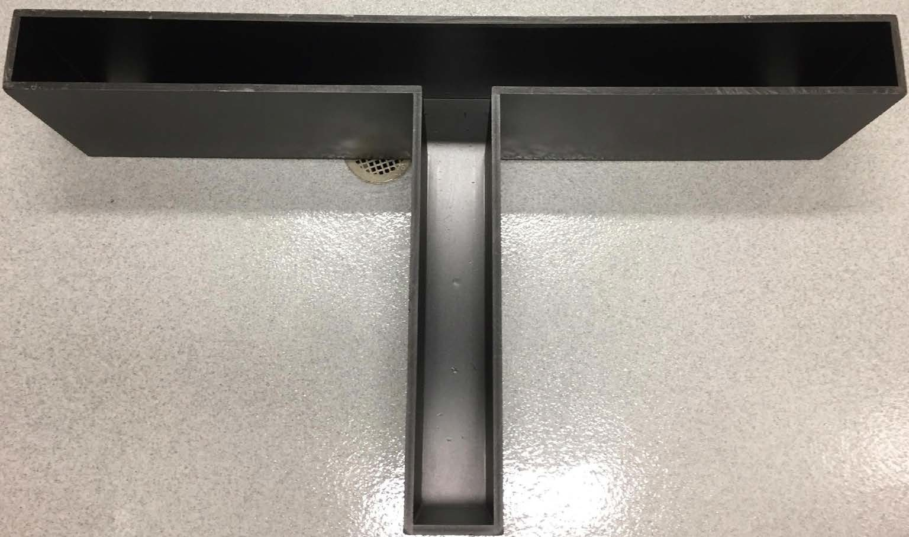
Procedure: T-maze (Salamone et al., 1994; Bardgett et al., 2009)
  - Diets ad-libitum for 21 days
  - Limited amount of food starting testing day
  - Habituation: In groups of two for ten minutes
  - Learning: Randomly assigned to baited arm
    - First, un-baited arm is blocked
    - Next, the baited arm is blocked
  - Discrimination I: Access to both arms
    - Removed after consuming the reward or reaching the end of the non-baited arm (10 trials per day until >90% correct)
Methods Continued…

- Discrimination I: Access to both arms
Effects of Diet on Learning Abilities in Old Rats
Ji Min Lee, Tahmarah Otoo, Amanda Jaimes, Arlene Martinez, Patrick Alcantara, Barbara J Cherry, and Jennifer Trevitt Department of Psychology, California State University, Fullerton
  - Removed after consuming the reward or reaching the end of the non-baited arm (10 trials per day until >90% correct)
- Discrimination II: Discrimination after baited and unbaited arms switched

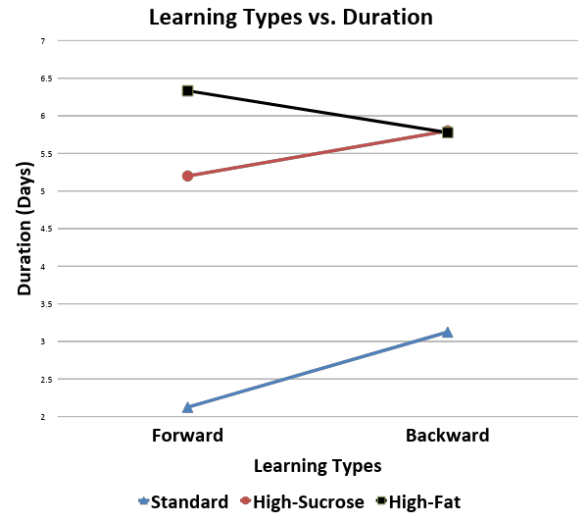
Results

- Rats on nutritionally balanced standard diet (M=2.625) learned significantly faster than the rats on the high-sucrose (M=5.50) and high-fat diet (M=6.056)
- No significant difference in learning abilities between specialized diets or types of learning

Conclusion
- Hypothesis that the rats on nutritionally balanced diet would show a greater learning capacity than experimental groups supported
- Hypothesis that there would be a difference in learning abilities between high-sucrose and high-fat diets not supported
- Neural rewiring, cell atrophy, or network alteration due to different diets possible (Attuquayefio et al., 2016)
- High-fat diets could lead to atherosclerosis (Beilharz, Maniam, & Morris, 2014).
- Recommend larger sample size and better external factors control in the future

References
Attuquayefio, T., Stevenson, R., Boakes, R., Oaten, M., Yeomans, M., Mahmut, M., & Francis, H. (2016). A high-fat high-sugar diet predicts poorer hippocampal- related memory and a reduced ability to suppress wanting under satiety. Journal Of Experimental Psychology: Animal Learning And Cognition, 42(4), 415-428. http://dx.doi.org/10.1037/xan0000118
Bardgett, M., Depenbrock, M., Downs, N., Points, M., & Green, L. (2009).
Dopamine modulates
effort-based decision making in rats. Behavioral Neuroscience, 123(2), 242-251. http://dx.doi.org/10.1037/a0014625
Beilharz, J., Maniam, J., & Morris, M. (2014). Short exposure to a diet rich in both fat and sugar
or sugar alone impairs place, but not object recognition memory in rats. Brain, Behavior, And Immunity, 37, 134-141.
http://dx.doi.org/10.1016/j.bbi.2013.11.016
Salamone, J., Cousins, M., & Bucher, S. (1994). Anhedonia or anergia? Effects of haloperidol
and nucleus accumbens dopamine depletion on instrumental response selection in a T-maze cost/benefit procedure. Behavioural Brain Research, 65(2), 221-229. http://dx.doi.org/10.1016/0166-4328(94)90108-2
Ye, X., Gao, X., Scott, T., & Tucker, K. (2011). Habitual sugar intake and cognitive function
among middle-aged and older Puerto Ricans without diabetes. British Journal Of Nutrition, 106(09), 1423-1432. http://dx.doi.org/10.1017/s0007114511001760

