Resilience in the Face of Chronic Pain

Afton L. Hassett, Psy.D.
Associate Research Scientist Chronic Pain & Fatigue Research Center
Department of Anesthesiology University of Michigan
Ann Arbor, Michigan, USA

Resilience in the Face of Chronic Pain

TOPICS
- Understanding the nature of pain helps us understand the potential power of resilience.
- The emergence of positive psychology and its implications for physical health.
- Positive affect and resilience – implications for individuals with chronic pain.
- Integrating positive affect skills into everyday practice and life.

The nature of pain.

These studies tell us three very important things about the nature of pain:
- Thoughts, emotions and pain are all neural events processed by some of the same areas of the brain,
- Damage/tissue injury can be optional in the experience of pain,
- Psychological, affective (emotional) and attentional processes are associated with the experience of pain.

Pain is much, much more than simple stimulus and response.

The nature of fibromyalgia pain.


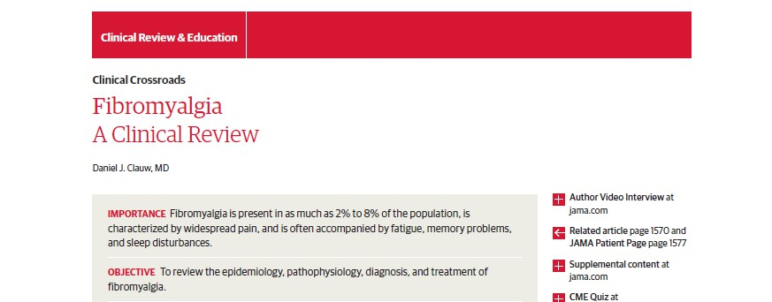

Mechanistic Characterization of Pain
Any combination may be present in a given individual

Peripheral (nociceptive) |  | Neuropathic | ( | Central  non-nociceptive)
- Inflammation or mechanical damage in tissues
- NSAID, opioid responsive
- Responds to procedures
- Classic examples
  - Acute pain due to injury
  - Osteoarthritis
  - Rheumatoid arthritis
  - Cancer pain
- Damage or dysfunction of peripheral nerves
- Responds to both peripheral (NSAIDs, opioids, Na channel blockers) and central (TCA’s, neuroactive compounds) pharmacological therapy
- Classic examples
  - Diabetic neuropathic pain
  - Post-herpetic neuralgia
- Characterized by central disturbance in pain processing (diffuse hyperalgesia/allodynia)
- Responsive to neuroactive compounds altering levels of neurotransmitters involved in pain processing
- Classic examples
  - Fibromyalgia
  - Irritable bowel syndrome
  - TMJD
  - Tension headache
Slide credit: Daniel J Clauw, MD

Pain sensitivity in the general population.

- Like most other physiological processes, we have a “volume control” setting for how our brain and spinal cord processes pain1

- This is likely set by genetic factors2-4 and modified by neurohormonal factors, neural plasticity and environmental factors

- The higher the volume control setting, the more pain we will experience, irrespective of peripheral nociceptive input

1. Mogil JS. PNAS, 1999;96(14):7744-51. 2. Amaya et. al. J

% of Population

16
14
12
10
8
6
4
2
0
Diffuse hyperalgesia or allodynia

Neuroscience 2006;26(50):12852-60. 3. Tegeder et.al., Nat Med. 2006;12(11):1269-77. 4. Diatchenko et. al. Hum Mol Genet. 2005;14(1):135-43.
Tenderness

Ten to fifteen percent of the population at risk for a
centralized pain disorder
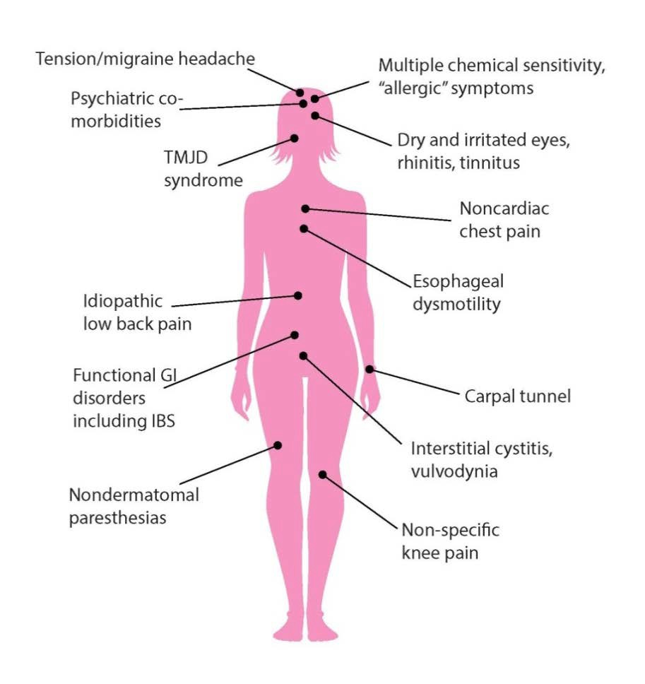
Tremendous overlap, widespread pain = fibromyalgia

“Prone” to Chronic Pain

Pain Prone Phenotype
- Female
- Early life trauma
- Family and/or personal history of chronic pain (youth)*
- Chronic centrally-mediated symptoms (fatigue, poor sleep, cognitive)
- Negative thoughts, affective disturbance
- Diffuse hyperalgesia, attenuated descending analgesia

Adapted from DJ Clauw- With permission
New or different region of chronic pain
Exposure to “stressors” or acute, peripheral nociceptive input (incl. emotional pain)

Negative Affect

Negative affect:

  - Sadness
  - Fear
  - Anger
  - Guilt
  - Shame
  - Loneliness
  - Frustration
  - Jealousy
  - Disgust

Negative affect associated with chronic pain

- Numerous studies linking negative affect to key factors in chronic pain:
  - Higher clinical pain intensity
  - Higher pain report
  - Worse weekly pain
  - Lower pain tolerance
  - Increased experimental pain sensitivity
  - Less tolerance to pain
  - Hyperalgesia
  - Greater use of pain medication
  - Worse analgesia (pentazocine)
  - Pain-related disability
  - Increased fatigue
  - More physical symptoms
  - Greater impact of pain on cognition
  - Higher levels of psychiatric comorbidity
  - Poor quality of life
  - Poor self-efficacy for pain management

Abeare et al. Clin J Pain 2010;26:683-9 Cogan et al. J Behav Med 1987;10:139-44 Carcoba et al. J Addict Dis 2011;30:258-70 Fillingim et al. Biol Psychol 2005;69:97-112 Finan et al. Psychosom Med 2009;71:474-82 Finan et al. Health Psychol 2010;29:429-37
Finan et al. Psychosom Med 2013; 75:463-470 Hamilton et al., Ann Behav Med 2005;29:216-24 Hanssen et al. Pain 2013;154:53-8
Hassett et al., Arthritis Rheum 2008; 59:1742-9 Hassett et al., Arthritis Rheum 2008; 59:833-40 Hirsch et al. Qual Life Res 2012;21:18794 Kamping et al. Pain 2013; Epub ahead of print
Kenntner-Mabiala et al. Biol Psychol 2008;78:114-22 Krok and Baker. J Health Psychol 2013; In Press Parrish et al. Health Psychol 2008;27:694-702 Schon et al. Psychophysiology 2008;45:1064-7 Seeback et al. Pain 2012;153:518-25
Siblile et al. Clin J Pain 2012;28:410-7 Smith et al. Pain 2008;138:354-61 Staud et al. Pain 2003;105:215.22
Staud. Curr Pain Heachache 2005.9:316-21 Stran et al. J Psychosom Res;60:477-84 Tang et al. Pain 2008;138:392-401
Vwesteeg et al. Qual Life Res 2009;18:953-60 Wesler et al. J Psychosoc Oncol 2013;31:451-67 Zautra et al. Pain 2007;128;128-35
Zautra et al. J Consult Clin Psychol 2005;73:212-20

The deadly nature of pain?
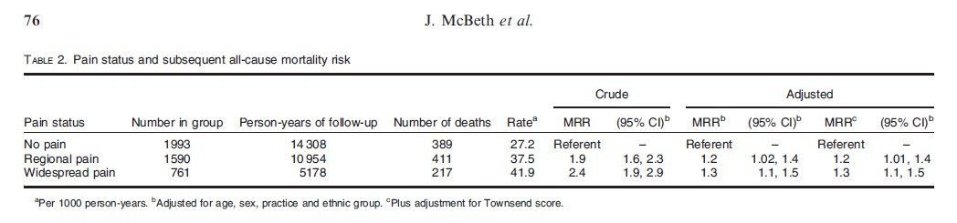

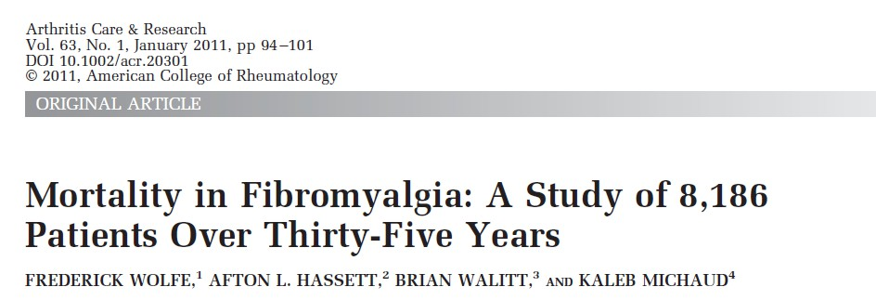
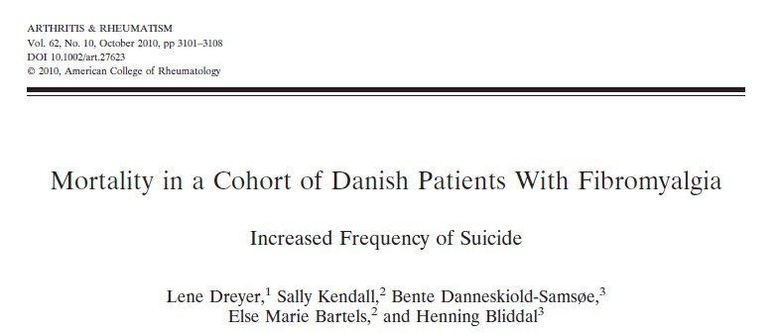

McBeth et al., Rheumatology2009;48:74-7; Wolfe et al. Arthritis Care Res 2010;63:94-101
Dreyer et al. Arthritis Rheum 2010;62:3101-8

The nature of pain – premature aging



Hassett et al. J Pain 2012;13:959-69

The nature of pain – premature aging

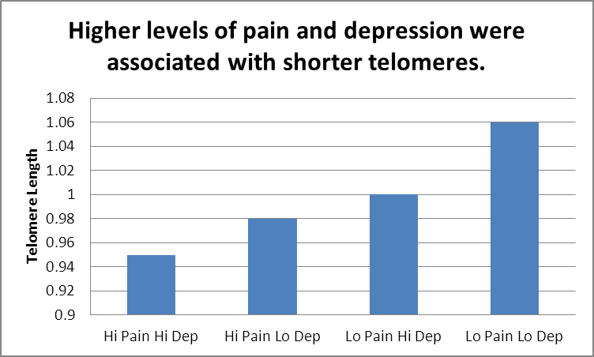


The difference between groups 1 and 4 was equivalent to > 6 years of aging.

The nature of pain – premature aging
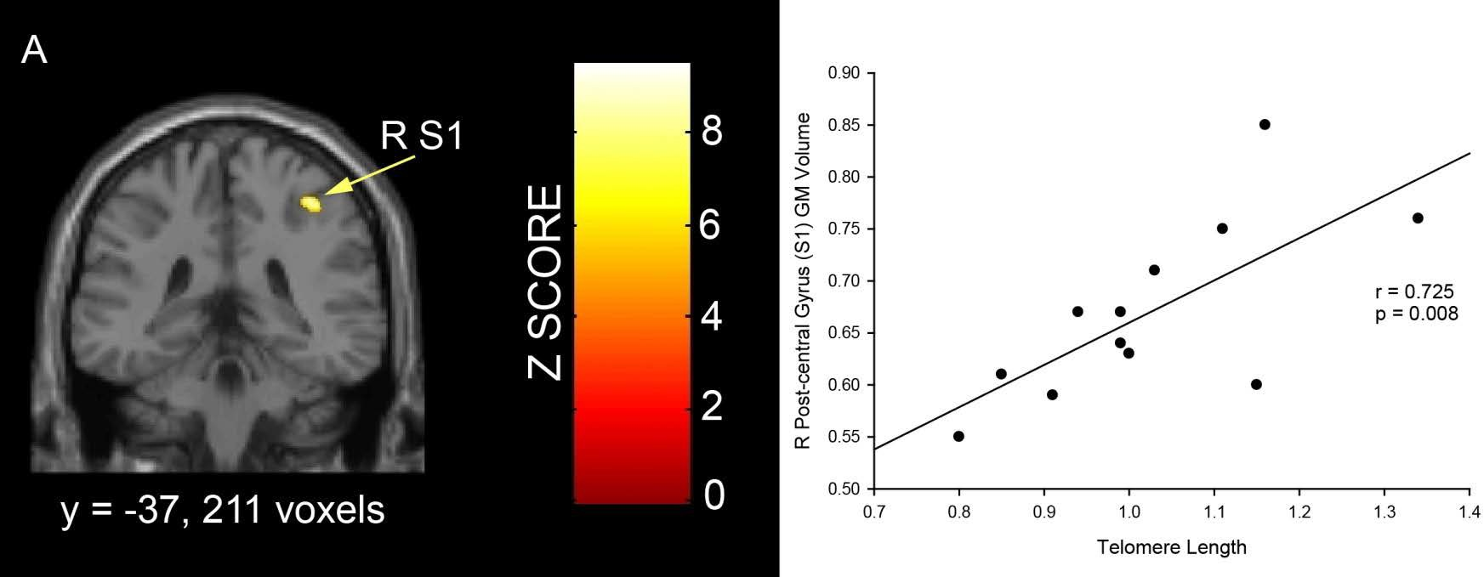
Statistical parametric map indicating brain regions showing a significant positive correlation between gray matter volume and telomere length.

Fibromyalgia patients with shorter telomeres showed less GM volume in right primary somatosensory cortex.
.
Hassett et al. J Pain 2012;13:959-69

The promise of Positive Psychology

Promoting resilience as a science

- The science of human behavior, derived from the Greek word 'psyche' meaning spirit, or soul.
- Psychology has become associated with psychopathology –
what is wrong with the person.

- The goal has been to ameliorate the ‘bad’ (depression, anxiety, dysfunctional cognitions) - to return the person to a state consistent with the absence of ‘bad’.

- “The aim of positive psychology is to catalyze a change in psychology from a preoccupation only with repairing the worst things in life to also building the best qualities in life”
Martin E. P. Seligman

Promoting resilience as a science
Presenter
2014-05-30 21:56:28
--------------------------------------------
North of ZERO – we do not ignore the below zero constructs, we treat these maladies aggressively but we also focus on resilience. Walk and Chew Gum

ZERO
Depression, anxiety, hostility, negative affect
Social support, well-being, positive affect

Resilient individuals with chronic pain
Presenter
2014-05-30 21:56:28
--------------------------------------------
Kind of like Marty Seligmans dogs

Resilient Subgroups

- No study to date in patients with chronic pain has demonstrated that all of the patients evaluated had a particular negative trait, psychiatric comorbidity, dysfunctional behavior, or set of unfortunate circumstances.

- Always a resilient subgroup – about 30% of patients.

The power of positive affect!!!
Presenter
2014-05-30 21:56:28
--------------------------------------------
This is just one example of a phenomenon observed on numerous occasions …

Positive affective variables in many cases are more powerful predictors of health outcomes than negative affective variables!

Positive affect a better predictor of outcome in pain?

- Solid prospective and experimental studies found PA related to:
  - Lower overall pain ratings
  - Lower pain intensity scores
  - Decreased same day pain report
  - Decreased subsequent day pain report
  - Decreased subsequent week pain report
  - Increased induced pain tolerance
  - Decreased induced pain sensitivity
  - Longer tolerance to pain
  - Evoked potential moderation
  - Decreased use of pain medication
  - Lower post-op pain ratings
  - Greater walking times post-surgery
  - Length of stay in colorectal cancer surgery
Adams et al. Activities, Adaptation and Aging 1986;8:157-75 Alden et al. Appl Psychophysiol Biofeedback 2001;26:117-26 Avia et al. Cognit Ther Res 1980;4:73-81
Bruel et al. Pain 1993;54:29-36.
Chaves et al., J Abnorm Psychol 1974;83:356-63 Clum et al. Pain 1982;12:175-83
Cogan et al. J Behav Med 1987;10:139-44 Connelly et al., 2007;131:162-70
Finan et al. Psychosom Med 2009;71:474-82 Finan et al. Health Psychol 2010;29:429-37 Finan et al. Psychosom Med 2013; 75:463-470 Gil et al., Health Psychol 2004;23:267-74 Hamilton et al., Ann Behav Med 2005;29:216-24 Hanssen et al. Pain 2013;154:53-8
Hertel et al. Psychol Rec 1994;33:207-20 Horan et al. Percept Mot Skills 1974;39:359-62 Hudak et al. Psychol Rep 1991;69:779-86 Kamping et al. Pain 2013; Epub ahead of print
Kenntner-Mabiala et al., Biol Psychol 2008;78:114-22 Meagher et al., Psychosom Med 2001;63:79-90 Morgan et al. Percept Mot Skills 1978;47:27-39 Pickett et al. J Consult Clin Psychol 1982 ;50:439-41 Powell et al., Rehabil Psychol 2009;54:83-90 Rosenbaum et al. J Abnorm Psychol 1980;89:581-90 Sharma et al., Colorectal Dis 2008;10:151-6
Stevens et al. Psychol Rep 1989;64:284-6 Strand et al., J Psychosom Res 2006;60:477-84 Tang et al., Pain 2008;138:292-401
Weaver el al. Percept Mot Skills 1994;78:632-4 Weisenberg et al. Pain 1998;76:365-75 Worthington et al. J Couns Psychol 1981;28:1-6 Zautra et al. J Consult Clin Psychol 2005;73:212-20 Zelman et al. Pain 1991;36:105-11

Positive affect plus

Presenter
2014-05-30 21:56:28
--------------------------------------------
Many positive affective variables

Positive affect can be a specific construct, e.g., as measured by the PANAS, or an “umbrella” term that enables the study of a number of factors associated with resilience.
- Self-efficacy
- Social support
- Psychological well-being
- Internal locus of control
- Extraversion
- Hardiness, perseverance, grit
- Optimism
- Determination/courage
- Benefit finding, gratitude & PTG
- Spirituality and prayer
- Forgiveness
- Sense of coherence

Fibromyalgia

Positive affect and Fibromyalgia


- PA associated with lower levels of:
Presenter
2014-05-30 21:56:28
--------------------------------------------
Many positive affective variables
  - Pain1
  - Fatigue2
  - Pain catastrophizing3
  - Psychiatric comorbidity4
- Deficit of PA!! Flat or normal levels of NA
- With elevated stress, a greater loss in positive affect (PA) is seen in FM compared to other chronic pain conditions. Plus, inability to sustain PA in stressful times adds to pain and fatigue.5
- Zautra: dysfunctional positive affect regulation (the lack of ability to sustain positive affect during times of increased pain or stress)
- New evidence – less efficient in modulating pain by positive affect (compared to health controls).6

1) Zautra et al. J Consult Clin Psychol 2005;73:212-20 2) Zautra et al Pain. 2007;128:128-35 3) Hassett et al. Ann Rheum Dis 2008;67 S254 4) Hassett et al. Arthritis Rheum 2008;59:833-40 5) Finan et al. Psychosom Med 2009;71:474-82. 6) Kamping et al. Pain In Press

Affective balance and pain
Presenter
2014-05-30 21:56:28
--------------------------------------------
And for our second R01, data from the comorbidity study laid the groundwork

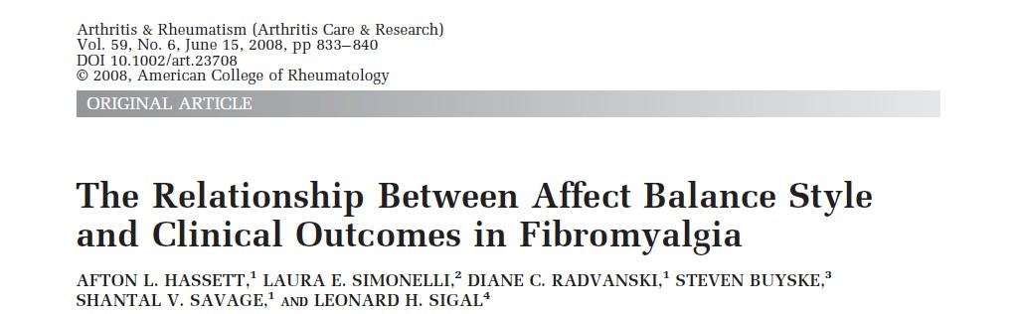

- Fibromyalgia patients (n=79) and medical controls (n=92) were drawn from 240 patients assessed at the Lyme Disease Clinic of UMDNJ-Robert Wood Johnson Medical School.
NIMH K08 MH65360-01

.

Hassett et al., Arthritis Rheum 2008; 59:833-40

Affective balance and pain

  - Groups differed regarding affect balance style (P = 0.0061), with FM patients being more likely than controls to be categorized as:
    - Depressive (odds ratio 5.60)
    - Reactive (odds ratio 3.81).
  - Reactive and Depressive ABS were associated with greater pain (P = 0.001) and worse functioning (P < 0.0001) compared with Healthy ABS.
  - Reactive ABS were associated with the highest risk meeting DSM-IV criteria for having a Pain Disorder.
  - Significant association between ABS and psychiatric comorbidity (P < 0.0001), Depressive and Reactive ABS having a 9.00 and 4.75 odds ratio, respectively, of having psychiatric comorbidity compared with Healthy ABS.

Hassett et al., Arthritis Rheum 2008; 59:833-40

Affect and allostatic load

- Allostatic Load: the price the body pays for repeatedly responding to excessive stress and/or when the stress response fails to “turn off” when no longer needed.
  - Increased risk for:
    - Hypertension,
    - Cardiovascular disease,
    - Insulin dependent diabetes,
    - Abdominal obesity,
    - Cognitive dysfunction with aging.

McEwen. Physiol Rev 2007;87:873-904

Affect and allostatic load
Presenter
2014-05-30 21:56:28
--------------------------------------------
Research focus is elucidating the mechanisms underlying the

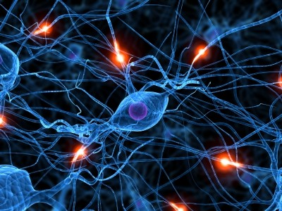
Psychobiological processes underlying the relationships between PA and health.

- PA associated with:
  - Cortisol output
  - Heart rate/HRV
  - Blood pressure
  - Inflammatory markers (IL-6)

- Relationships are independent of NA and depressed mood!

Steptoe et al., J Pers 2009;77:1747-76

Interventions that enhance resilience
Presenter
2014-05-30 21:56:29
--------------------------------------------
Many positive affective variables



Interventions that enhance resilience

Social Support Round Robin
- Make eye contact with somebody sitting next to you. Give him or her a fist bump.
- Take a moment and think about something you really like about that person.
- Choose something special about him or her that is generally seen as a character strength (creativity, intelligence, integrity, courage, sense of humor, perseverance).
- If this person is a stranger, choose something about his or her presentation or demeanor.
- If this person is somebody with whom you have a conflict, all the more important to identify something you like and/or respect.
- Now, tell the person what it is that you appreciate and/or admire.

Interventions that enhance resilience

Keeping a Gratitude Diary
- Every day, write down 5 things for which you are grateful. It can be anything - feeling the sunshine on your face, happy that a friend phoned, receiving a present, being able to take a walk, anything. Work out a time to do this. Ideally, around the same time every day works best.

- Make a commitment to yourself that you will write down 5 things every day - this is very important.
- The 5 things MUST be DIFFERENT each time. Never repeat anything.
- Smile as you write them down. This will help you to feel grateful.

- You can write a lot about each thing, get really detailed, write why you are grateful for it. Or if you don't have time, just write one line.

Interventions that enhance resilience

The Gratitude Visit
- Think of the people still alive — parents, friends, teachers, coaches, teammates, employers, and so on — who have been especially kind to you but have never heard you express your gratitude.
- Write and rewrite a Gratitude Letter to one of these individuals, describing in concrete terms why you are grateful. The letter should name the specific things they did for you, and exactly how it has affected your life. Tell them what you are doing now and how you often remember his or her efforts. Make it sing.
- Call the person in advance and make an appointment with them. Do not tell them the purpose of the visit except in vague ways, e.g., “there’s something important I would like to tell you about.”
- Deliver it personally and read the letter aloud to them in his or her presence. Then discuss with each other how you both feel about each other, about gratitude specifically, and about the future.

Seligman, Park & Peterson

Interventions that enhance resilience

Intentional Kindness - Everyday we do kind things and fail to recognize the frequency, meaning and appreciation by others of these small acts.
- In this exercise, you will on a daily basis do one intentionally kind thing for a loved one, one for a complete stranger and one for yourself.
- When you do these kind things for others, look the person in the eye and be gracious. Expect nothing in return, but acknowledge the gratitude if offered.
- When you do the kind thing for yourself, acknowledge the importance of self- care and kindness.
- Log these acts in a journal every day for seven days. Note what the act of kindness was and how doing it made you feel.

Hassett, Park & Peterson

Interventions that enhance resilience

Savoring a Beautiful Day:
  - Set aside a block of time for your own pleasures. Set aside a minimum of one hour or a maximum of a full eight-hour day. A half-day is just about perfect for the first time you do this exercise.

  - Block that time out on your calendar now, and do not let anything interfere, if possible. Next plan one activity or, even better, a sequence of activities that brings you real pleasure, and carry them out as you planned them.

  - Here is the further twist. Savor each of the activities using all of your senses and with feelings of gratitude and optimism.

Adapted from: Seligman, Park & Peterson

Distraction

Interventions that enhance resilience


- Good evidence for distraction through pleasant and engaging stimuli.
  - Imagery
  - Music
  - Video games
  - Toys
  - Virtual reality
  - Reading
  - Movies (engaging!)
- Concept of FLOW

Interventions that enhance resilience

- Concept of “Flow:” the mental state of operation in which the person is fully immersed in what he or she is doing by a feeling of energized focus and full involvement.
Mihaly Csikszentmihalyi


Example: Athlete absorbed in a competition
(remember Devin?)

Patient empowerment via technology.
Presenter
2014-05-30 21:56:29
--------------------------------------------
Developing this now.


Novel interventions based on the principles of positive psychology.
- Tailored for chronic pain
- Increase well-being and functional status
- Self-management or with HP coaches (nurses, PT, OT)
- Web-based, open access (CBT [FibroGuide], PPT)

Patient empowerment via technology.

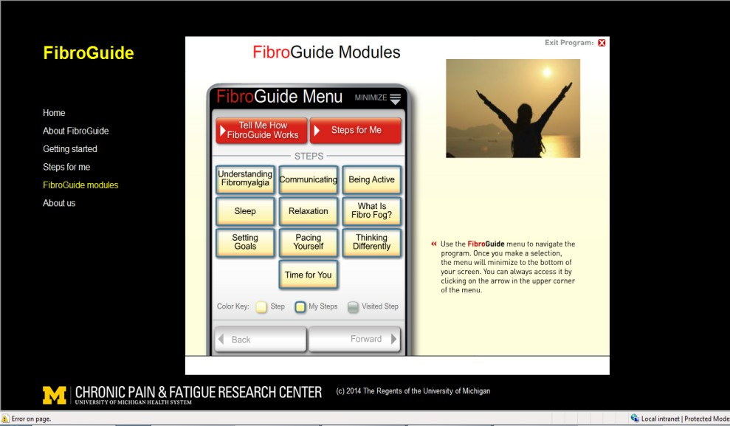
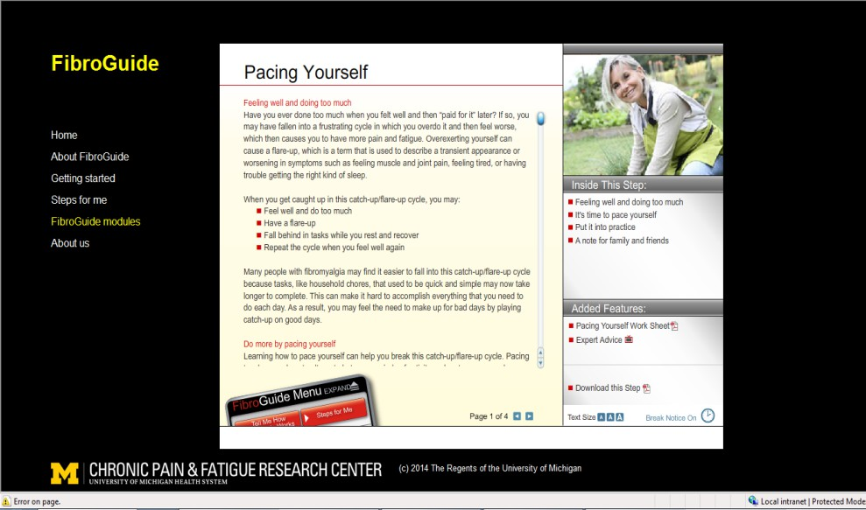
http://fibroguide.med.umich.edu/

Unmet needs?

How do we modify our approach to at risk patients?
  - Better assessment strategies (e.g., questionnaires, brief interviews)
  - Prophylactic medications (e.g., gabapentin, SNRIs)
  - Integrate non-pharmacological intervention (e.g., CBT, resilience)
  - Follow-up specific to psychiatric symptoms
  - Enhance environment and practices

Unmet needs?


Healing environment
- Music
- Soft lighting
- Attractive design, homey
- Therapeutic aromas

Interventions that enhance resilience
Presenter
2014-05-30 21:56:29
--------------------------------------------
Pediatric Anesthesiologist Medical College of Wisconsin


Expectations and Language
- Neil Farber, MD - use of “Comfort Scores”
  - “How comfortable are you?”
  - “What can we do to make you more comfortable?”
    - Opens possibility for: another pillow, drink of water, an additional blanket instead of more pain medication.
- Post Caesarean section recovery, women randomized to “comfort” or “pain” scores groups. Those in the comfort group reported less bother from the surgery, less pain unpleasantness and requested less analgesia.

Chooi et al. Br J Anaesth 2013;110:780-7

Comprehensive “intensive” care.
Presenter
2014-05-30 21:56:29
--------------------------------------------
Mayo Vanderbilt


Comprehensive multidisciplinary pain care in a healing environment.

Two-week intensive program for patients and family.

Comprehensive care.


Program and culture inspired by the principles of positive psychology.

Acknowledgments

Daniel J. Clauw, MD Chad M. Brummett, MD Jenna Goesling, Ph.D. Richard E. Harris, Ph.D. Steven E. Harte, Ph.D. Ronald Wasserman, MD David A. Williams, Ph.D.

Alex Tsodikov, Ph.D. Stephanie Moser, Ph.D. Jennifer Wolfe, MA Meghan McCloe, BA Taha Meraj, BS Baorong Shi, BS
Bilal Zaidi, BS


Funding:
National Institute of Mental Health Bristol-Myers Squibb, Inc.
American Society of Regional Anesthesia and Pain Medicine University of Michigan, Department of Anesthesiology

