Pain Catastrophizing as a Predictor of Physical Performance among Older

Adults with and without Fibromyalgia
Priyanka Taneja^{1,4}, Miriam Gamboa^{2,4}, Holly Steininger^{3,4}, and Jordan K. Aquino^{1,4}
1Department of Health Science, ²Department of Psychology, ³Department of Biological Sciences, ⁴Fibromyalgia and Chronic Pain Center


FIBROMYALGIA
- A chronic disorder characterized by widespread musculoskeletal pain, fatigue, and tenderness in localized areas
PAIN CATASTOPHIZING
- Pain Catastrophizing is defined by three characteristics
  - magnify the threat value of pain
  - feel helpless in the context of pain
  - inability to inhibit pain-related thoughts surrounding a painful event
PURPOSE
- Investigate whether pain catastrophizing predicts physical performance in people 50 years and older with and without Fibromyalgia
HYPOTHESIS
- Score of pain catastrophizing would predict physical performance scores
DEMOGRAPHICS

 | FM | Non-FM
N | 38 | 33
Female | 36 (94.7%) | 19 (57.6%)
Mean Age | 64.03 (SD= 6.75) | 71.30 (SD= 9.11)
Mean BMI | 29.78 (SD= 7.39) | 28.71 (SD= 6.61)
METHOD
- Participants came in for 2-3 hours on one day and completed questionnaires and a battery of physical and cognitive tests. The assessments below are relevant to this analysis.
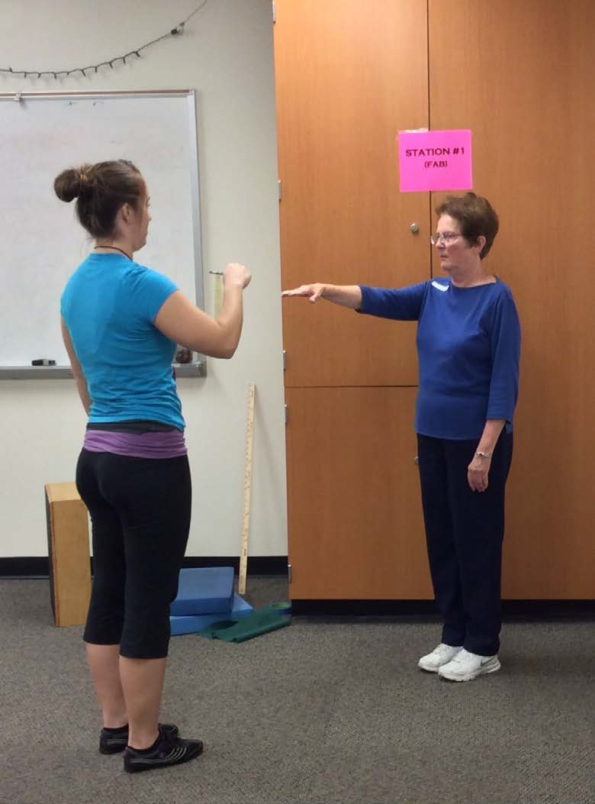
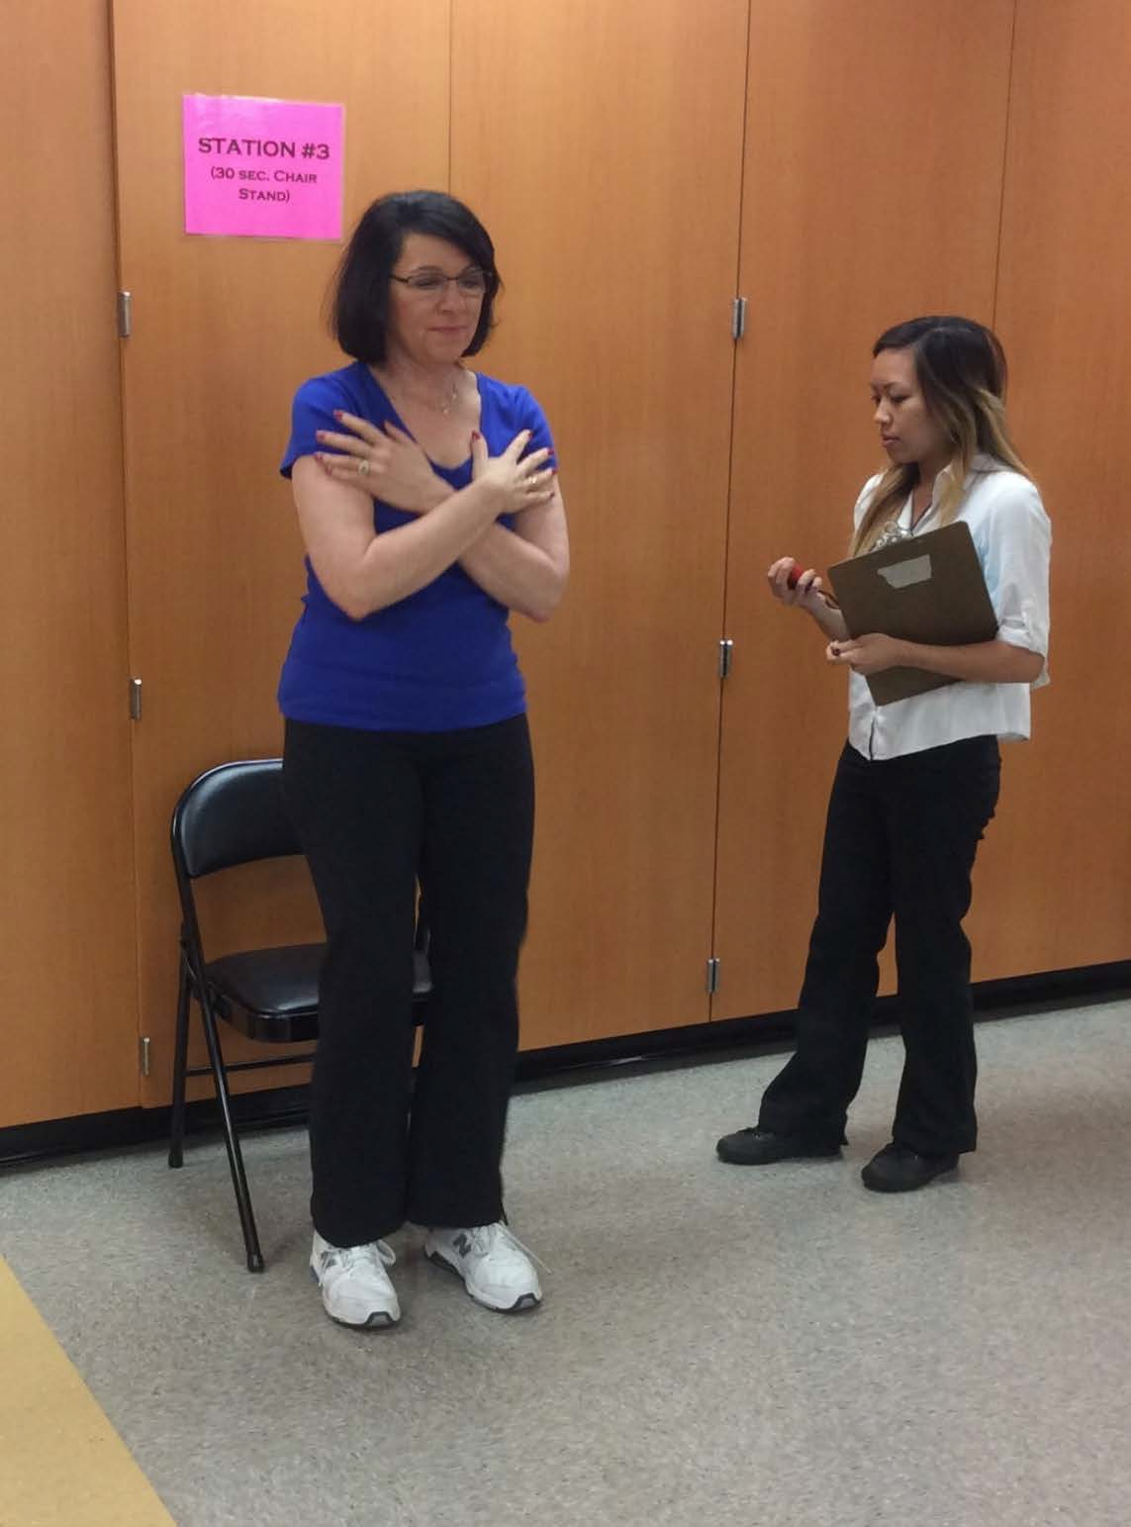
Picture 1 (Left): Illustrates a component of the Fullerton Advanced Balance Scale. Picture 2 (Right): Illustration of the 30 second chair stand.

Assessments | Measures
FAB- Fullerton Advanced Balance Scale | Multidimensional balance
30 sec. Chair stand | Lower body strength
8ft up and go | Physical mobility
30 ft. walk (preferred speed) | Normal gait velocity
30 ft. walk (fast speed) | Fast gait velocity
6 minute walk | Aerobic endurance
Pain Catastrophizing Scale (PCS) | 13 questions assessing the catastrophizing of pain  - Higher scores indicated higher levels of pain catastrophizing
Composite Physical Functional Scale (CPF) | 12 questions assessing a wide range of physical function  - Lower composite scores indicated greater physical functioning

Picture 3: Illustrates the set up for the 30ft. walk
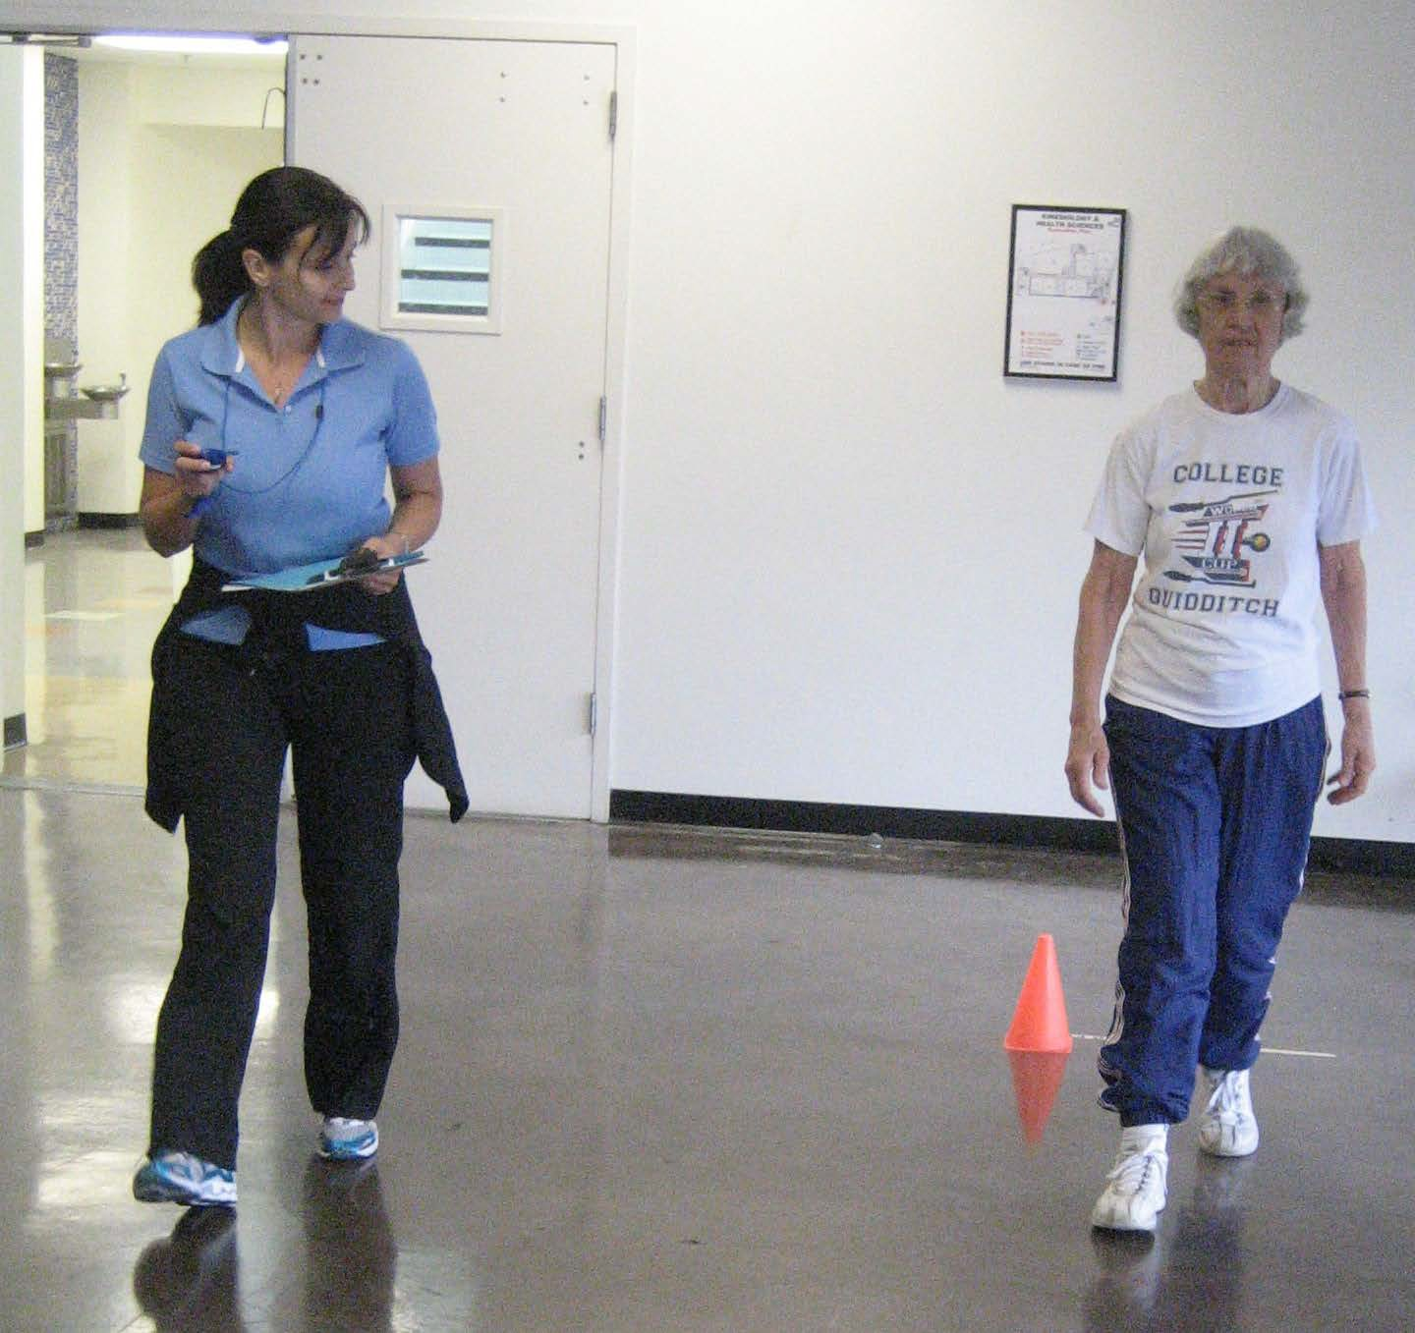

RESULTS
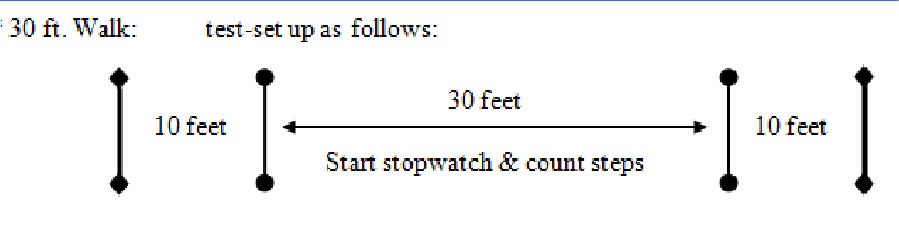
- Hierarchical regression analyses controlling for age, BMI, and Fibromyalgia status were conducted
- Pain catastrophizing predicted preferred velocity and composite physical function
- People with less pain catastrophizing had higher preferred velocity
Table 1. Regression Results for Age, Fibromyalgia Status, BMI, and Pain Catastrophizing Total Predicting FAB, 30 Second Chair Stand, 8 Minute Up and Go, 6 Minute Walk, 30 Foot Walk (Fast and Preferred), and Composite Physical Function.

Step 1 |  |  |  |  | Step 2
 |  | BMI | FM Status | Age | PCS Total
 | β | -0.39*** | -0.18 | -0.58*** | -0.15
FAB | ΔR² |  | 0.41*** |  | 0.02
30 Sec Chair | β | -0.12 | -0.25⁺ | -0.18 | -0.04
Stand | ΔR² |  | 0.08 |  | 0.00
 | β | 0.25* | 0.10 | 0.41** | 0.14
8ft Up & Go | ΔR² |  | 0.18** |  | 0.02
 | β | -0.38*** | -0.23 | -0.45*** | -0.12
6 Minute Walk | ΔR² |  | 0.35*** |  | 0.01
30ft. Walk | β | -0.28* | -0.17 | -0.29* | -0.03
(Fast) | ΔR² |  | 0.16* |  | 0.00
30ft. Walk | β | -0.28* | 0.12 | -0.26* | -0.31*
(Preferred) | ΔR² |  | 0.12* |  | 0.08*
 | β | -0.29** | -0.38*** | -0.06 | -0.31**
CPF | ΔR² |  | 0.33*** |  | 0.08**
Note: Coefficients are from final 2-step model; +p < 0.10, *p < 0.05, **p < 0.01,
***p <0.001
CONCLUSION
  - Preferred velocity did not have complex instructions—may have enabled participants to ruminate about their pain
  - Other physical assessments not performed on a daily basis-- participants may have been distracted by the instructions to perform to the best of their ability
  - Results suggest that people with chronic pain work through pain catastrophizing by focusing on other challenging tasks or skills
FUTURE RESEARCH
- Focus on levels of difficulty of instructions for challenging tasks
  - May act as distraction for people with chronic pain
  - See how pain catastrophizing is altered as a result of the complexity of the instructions
- Should see if reducing pain catastrophizing scores will reduce levels of depression and anxiety in people with fibromyalgia

