Sedentary Behavior, Depression, and BMI in Older Adults with Chronic Pain
Jasmine R. Victor ♦ Melissa Salmeron ♦ Laura Zettel-Watson Department of Psychology ♦ California State University, Fullerton

Background
Measures
Results


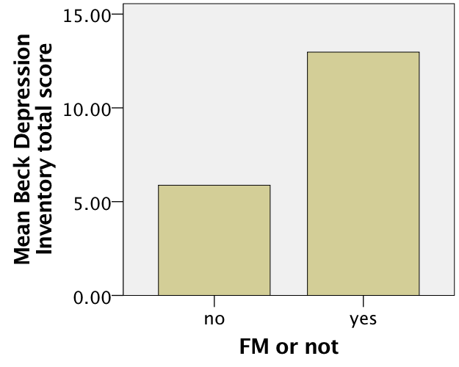
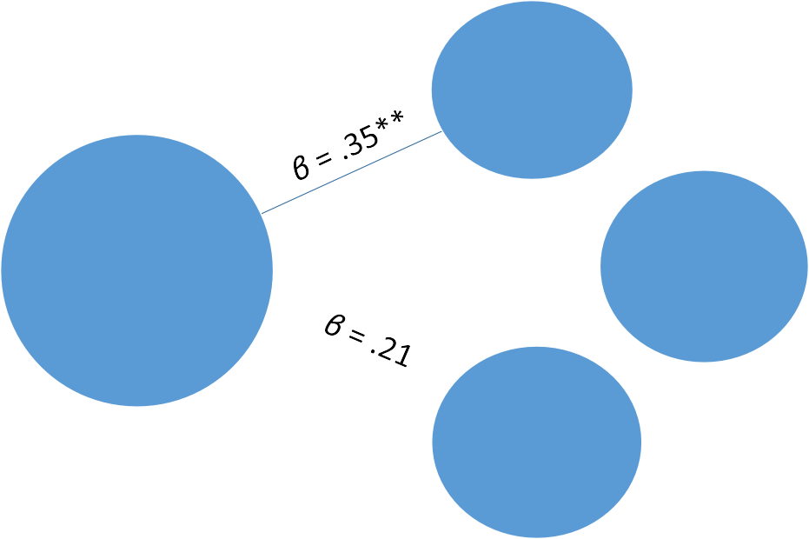
- Series of linear regression analyses (controlling for age and gender)
FM Status Predicting BMI, Depression, and Sedentary Behavior (N= 71)
Depression
FM Status
β = -.09
Sedentary
Behavior
BMI
** p < .01
- Demographics (Age, Gender, Education)

- Beck Depression Inventory II
  - 21-item self-report inventory measuring the severity of depression in adolescents and adults

- Sedentary Behavior Questionnaire; SBQ
  - 18-item self-report questionnaire measuring length of stationary activities done on a typical weekday and a typical weekend day

- Body Mass Index; BMI
- Calculated by height and weight
Analysis
- FM status only predictive of depressive symptoms (p<.01)

- Neither BMI nor sedentary behavior varied by FM status, after controlling for age and gender
- Fibromyalgia (FM): chronic musculoskeletal pain, fatigue, poor physical functioning, poor mental health

- Symptoms found in ~ 2-7%; prevalence increases with age, >7% in women 60-79 years

- FM often concurrent with other ailments (e.g., arthritis, lupus, irritable bowel syndrome)

- Significant relationships between: Chronic pain and sedentary behavior Chronic pain and obesity
Chronic pain and depression Sedentary behavior and depression

- Current study evaluates the relationship between FM, depressive symptoms, BMI, and sedentary behavior

- Hypothesis: individuals with FM will have higher sedentary behavior scores, higher BMI and greater depressive symptomology than those without FM
Conclusions

Method
- Findings contrary to expectations

- Results likely explained by methodological considerations

- Selective attrition in larger longitudinal study could be responsible for healthier FM participants and the consequential null results
- 2016 cross-sectional data derived from ongoing longitudinal study

- N= 71, Mage= 67.4, 77% female, 54% FM
- Participants completed psychological and physical assessments
Future Research
- Continued longitudinal study and cross- comparison of results

- Use activity trackers in combination with SBQ to compare self-report and performance measures

